NEW JERSEY STATE SURVEILLANCE

Weekly Report for Week 24, 8 June – 14 June, 2003

Submitted by Lisa Reed and Wayne Crans

Mosquito Research and Control Unit

Rutgers University, New Brunswick, NJ 08901
Figure 1a: Map of ten regions selected for the New Jersey Surveillance Program overlaid with county boarders. |  | Figure 1b. Trap lat-long locations.
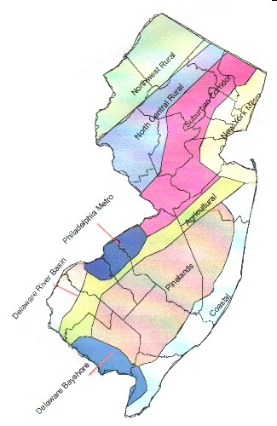 |  | 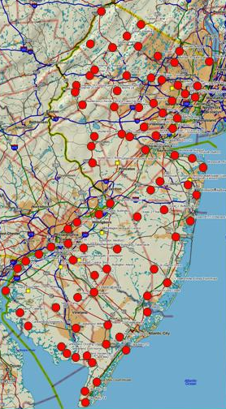
Preface: Data from 84 New Jersey light traps from all 21 counties are used to calculate trends in mosquito populations for species of nuisance or health concerns. Calculations are based on regional distributions, with emphasis on mosquito habitat and land use. Trends will allow a statewide evaluation of changing mosquito populations, in response to control and/or changes in habitat.
This is New Jersey Agricultural Experiment Station publication No. PT-40500-24-03 supported by Hatch funds and funding from the NJ State Mosquito Control Commission. Prepared by Lisa M. Reed and Wayne J. Crans.

Summary table
 | Aedes vexans |  | Culex complex |  | Ochlerotatus canadensis |  | Ochlerotatus sollicitans
Region | This Week | Average* | This Week | Average* | This Week | Average* | This Week | Average*
Agricultural | 2.83 |  | 6.03 |  | 0.10 |  | 0.38
Coastal | 0.00 |  | 0.38 |  | 0.00 |  | 0.00
Delaware Bayshore | 0.00 |  | 10.79 |  | 0.00 |  | 0.00
Delaware River Basin | 4.64 |  | 4.00 |  | 0.00 |  | 0.64
New York Metro | 0.39 |  | 6.71 |  | 0.01 |  | 0.64
North Central Rural | 0.20 |  | 1.18 |  | 0.00 |  | 0.00
Northwest Rural | 0.21 |  | 0.93 |  | 0.00 |  | 0.00
Philadelphia Metro | 2.05 |  | 1.71 |  | 0.00 |  | 0.00
Pinelands | 0.10 |  | 0.47 |  | 0.00 |  | 0.08
Suburban Corridor | 3.70 |  | 0.56 |  | 0.00 |  | 0.00

- Complete data not yet available.

Agricultural
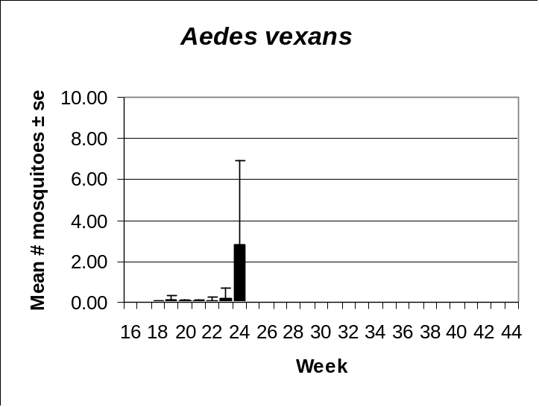 | 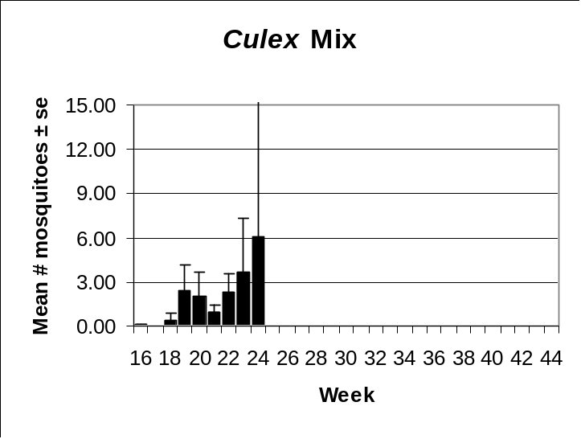
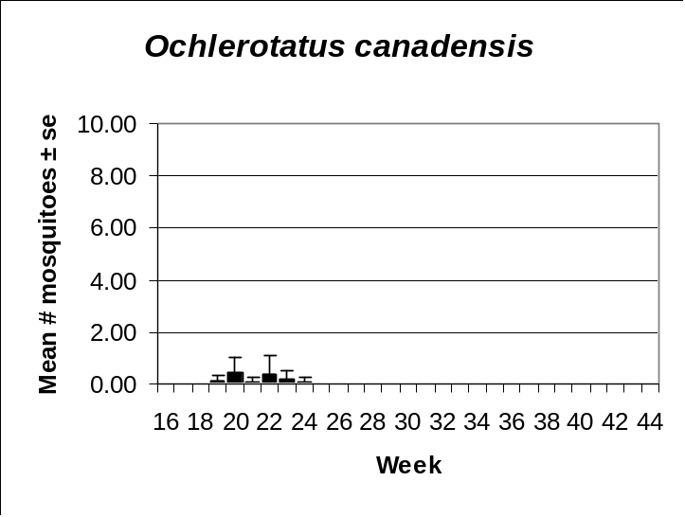 | 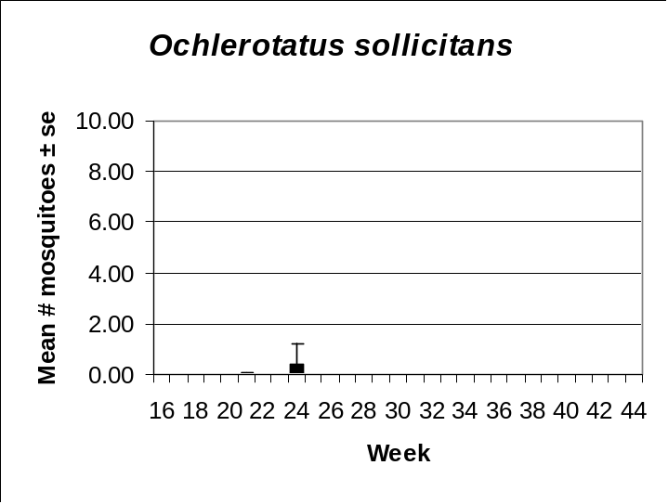

Coastal
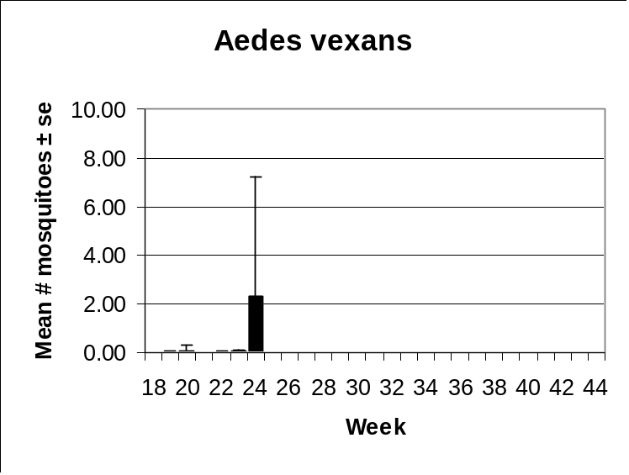 | 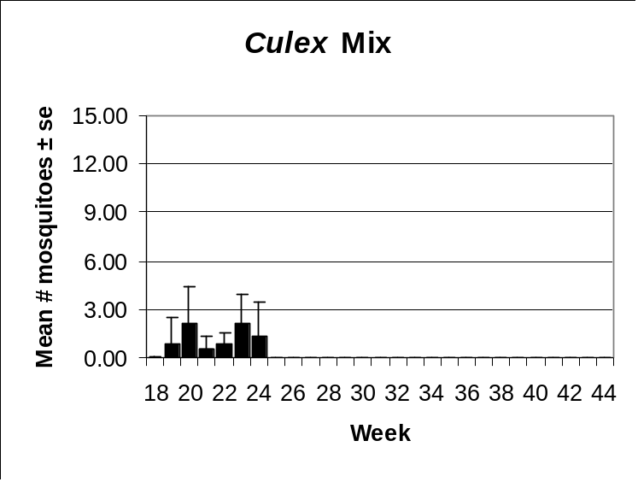
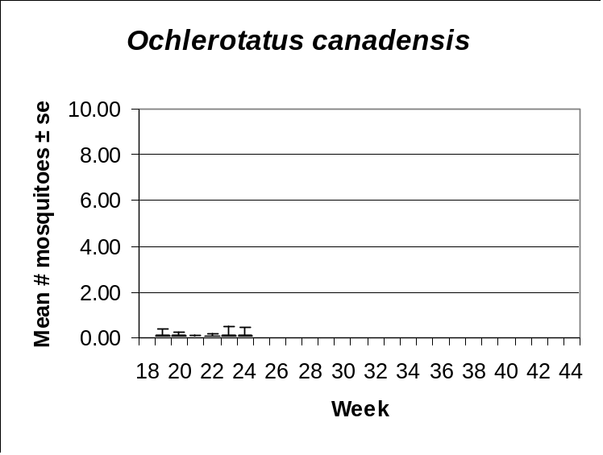 | 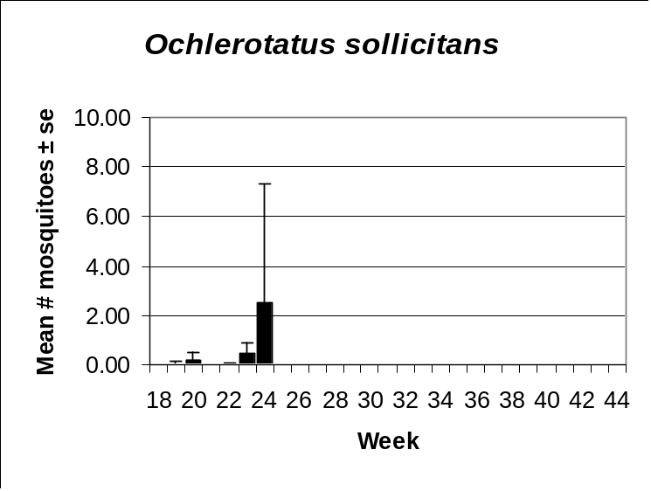

Delaware Bayshore
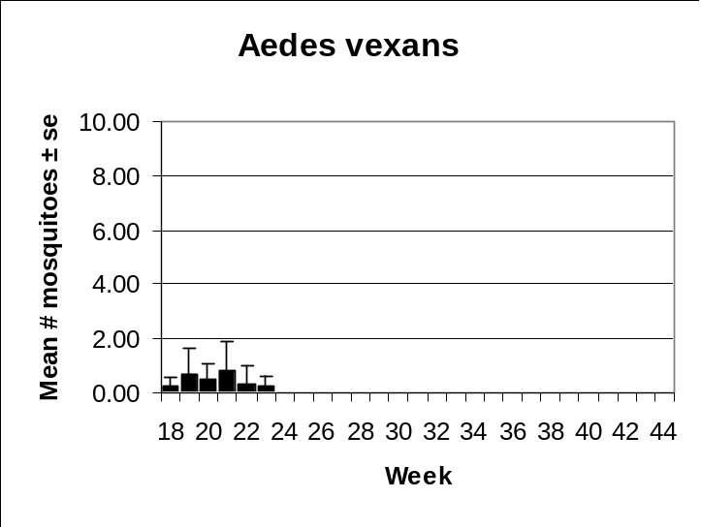 | 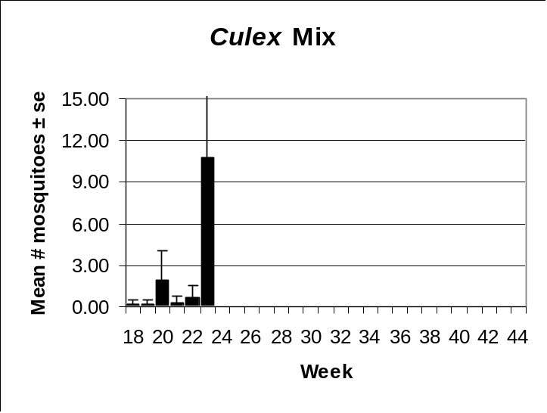
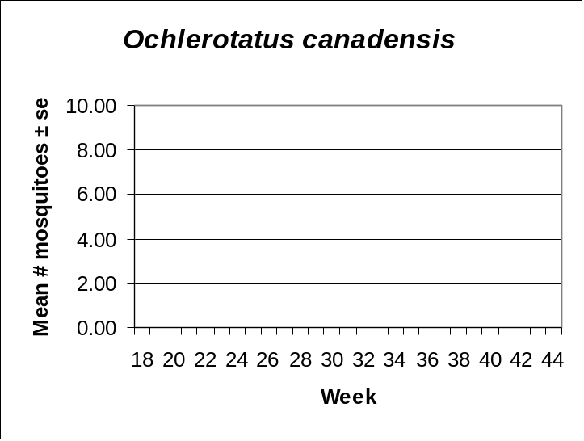 | 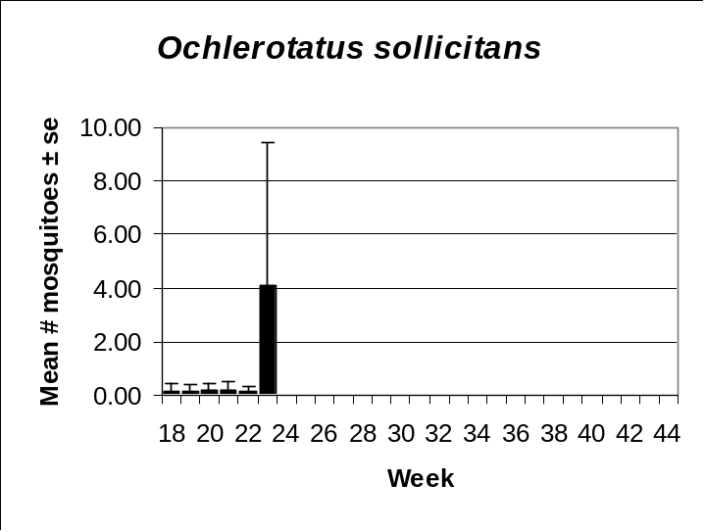

Delaware River Basin
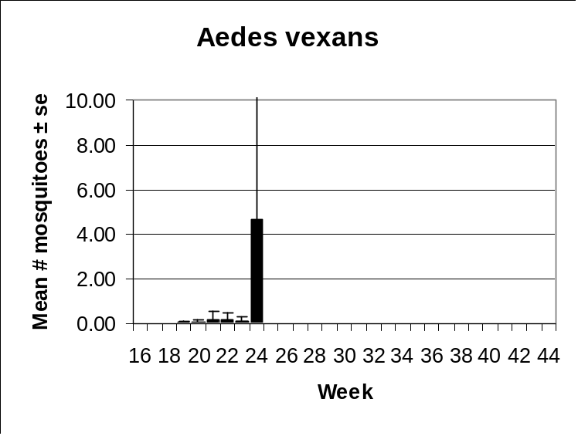 | 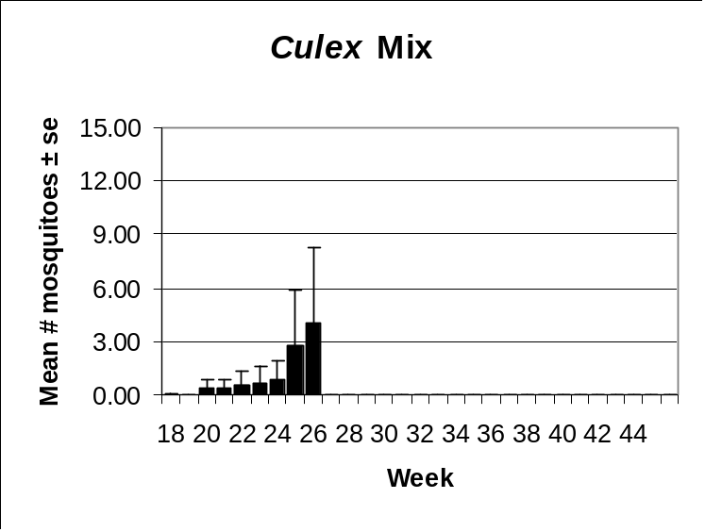
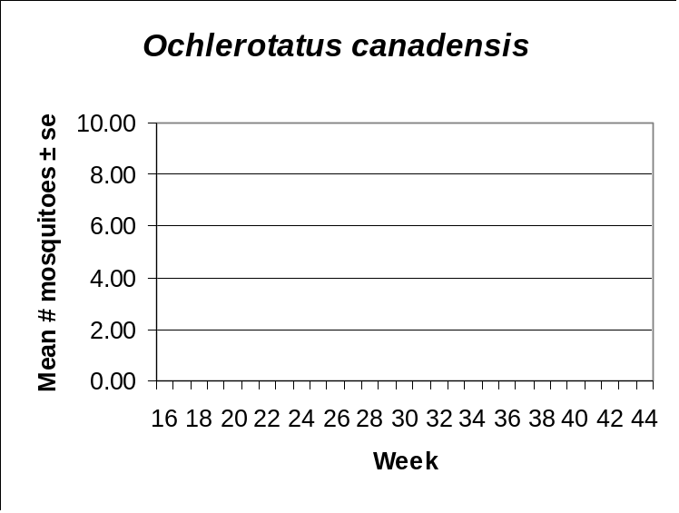 | 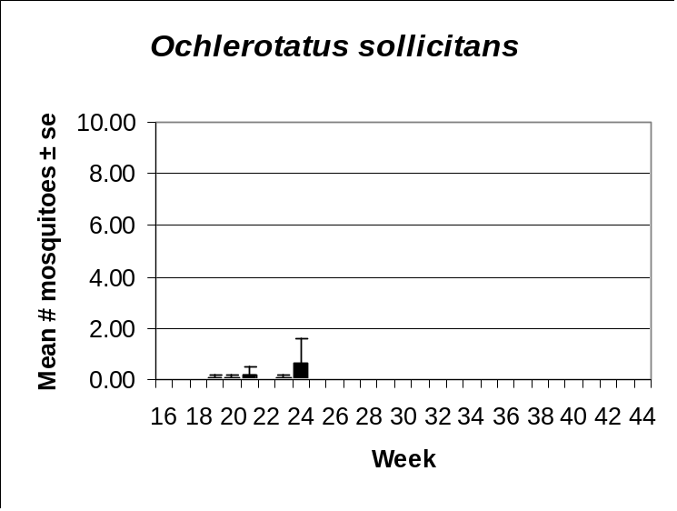

New York Metro
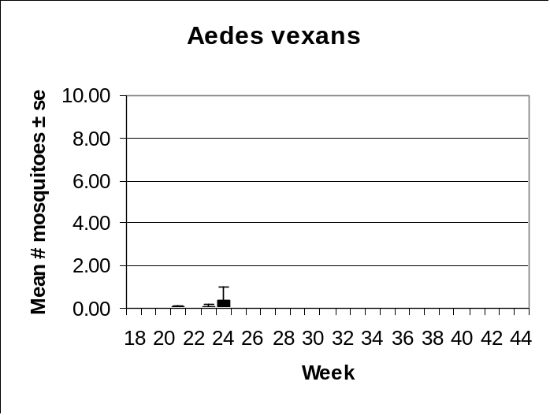 | 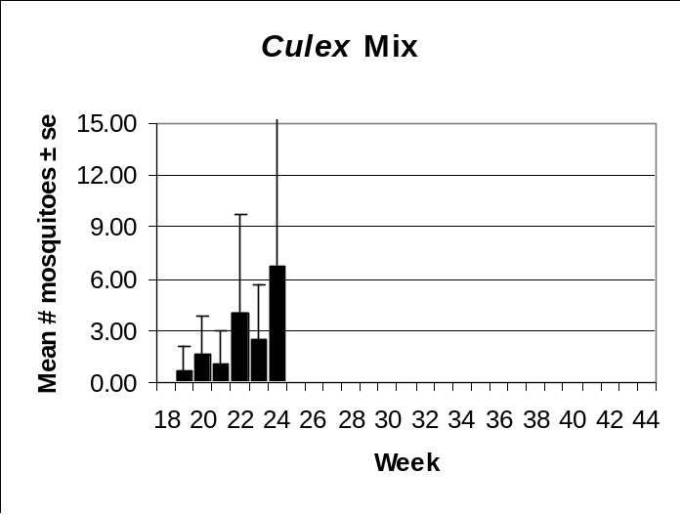
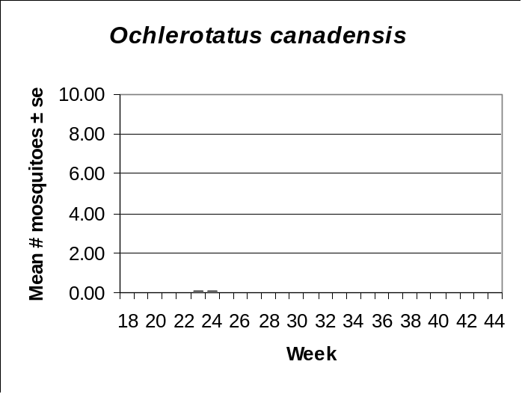 | 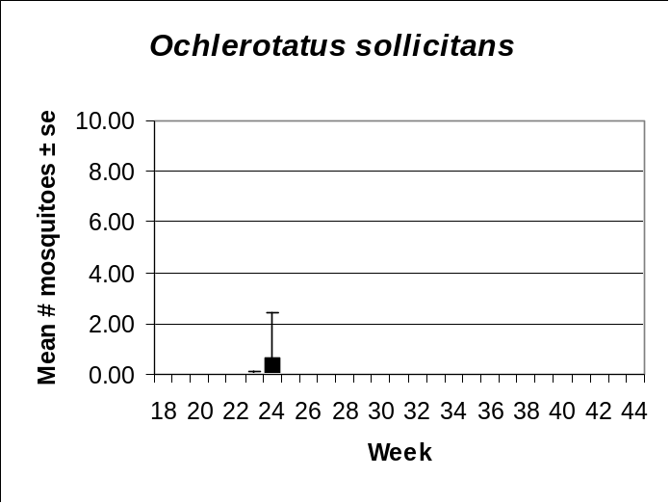

North Central Rural
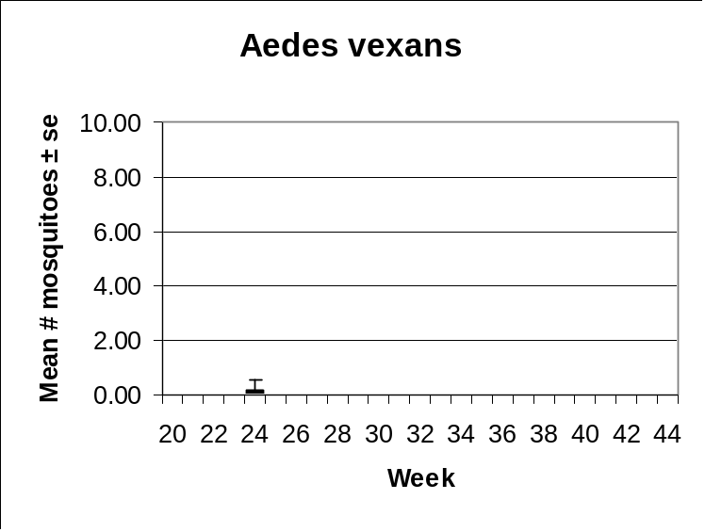 | 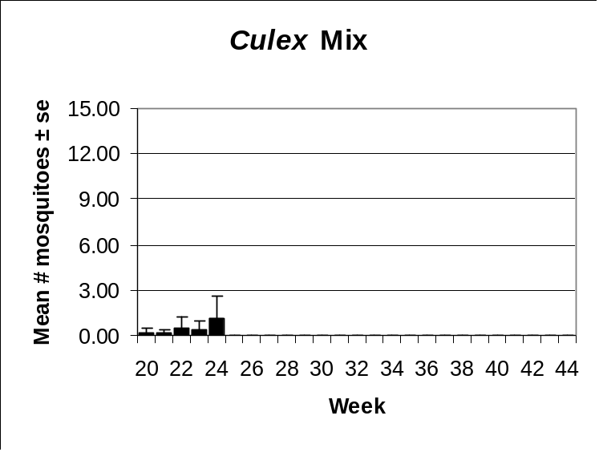
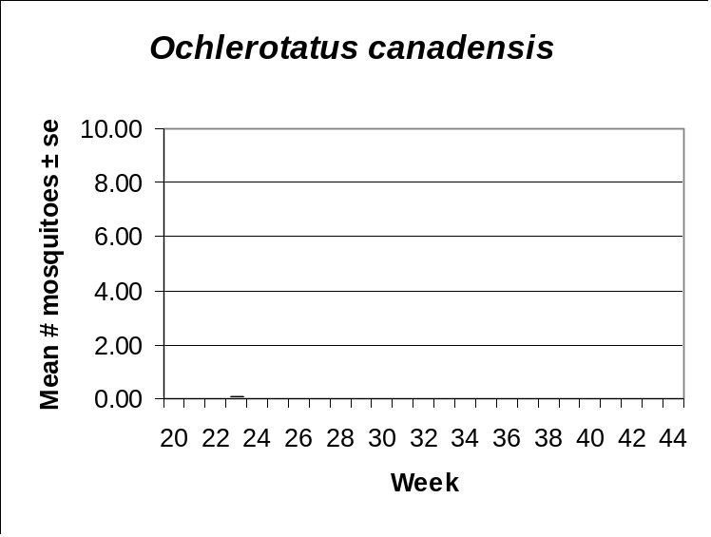 | 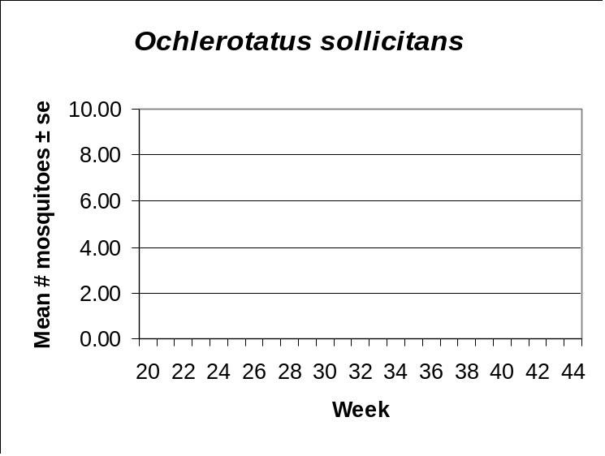

Northwestern Rural
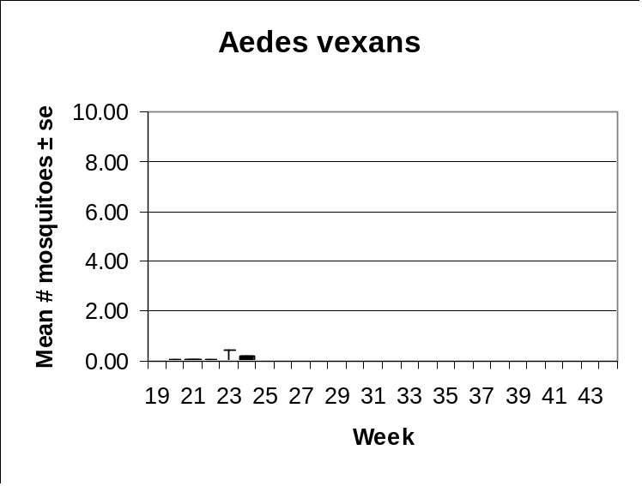 | 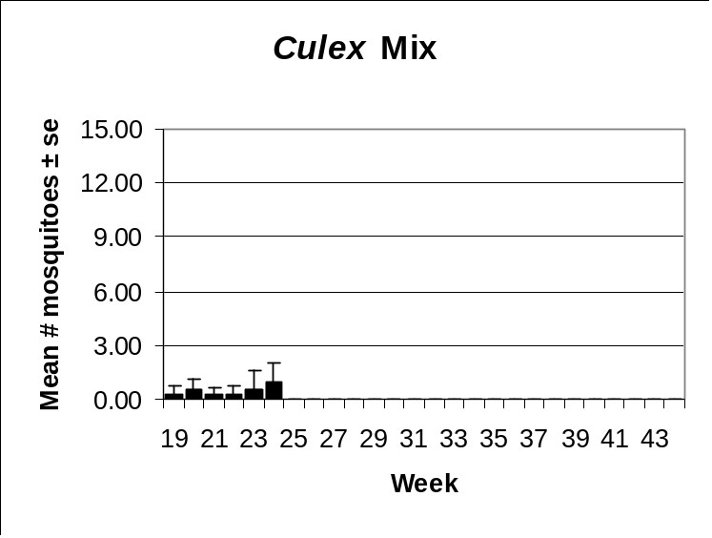
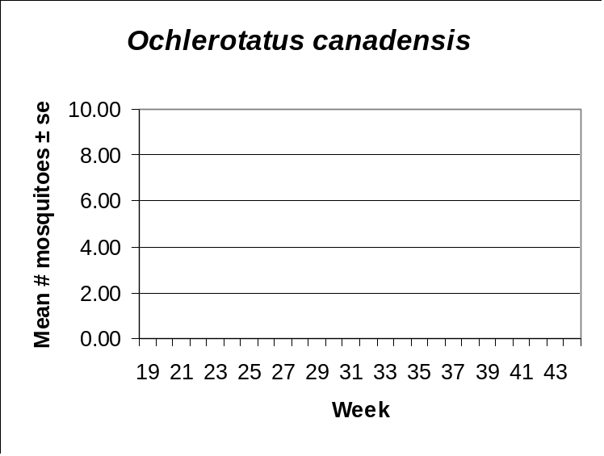 | 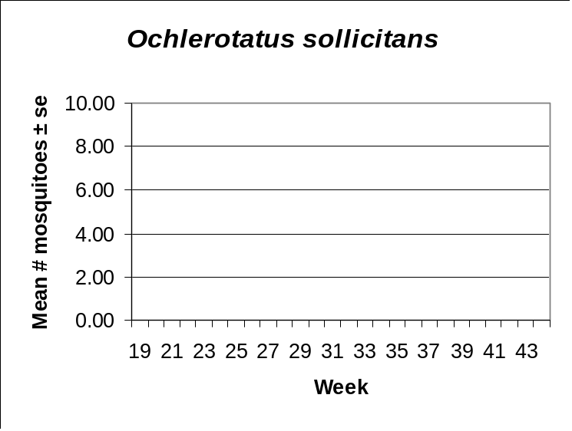

Philadelphia Metro
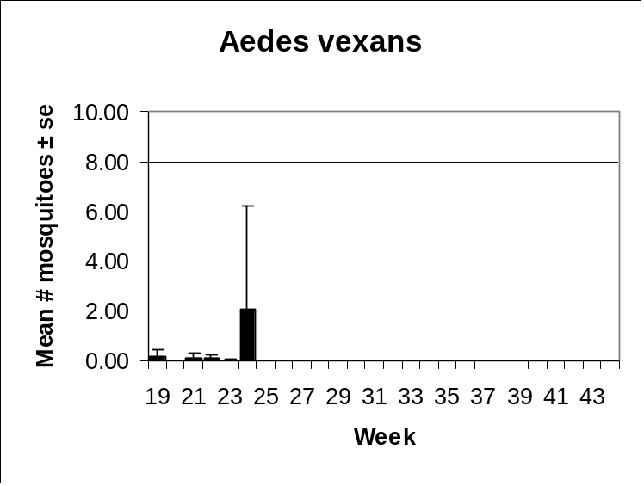 | 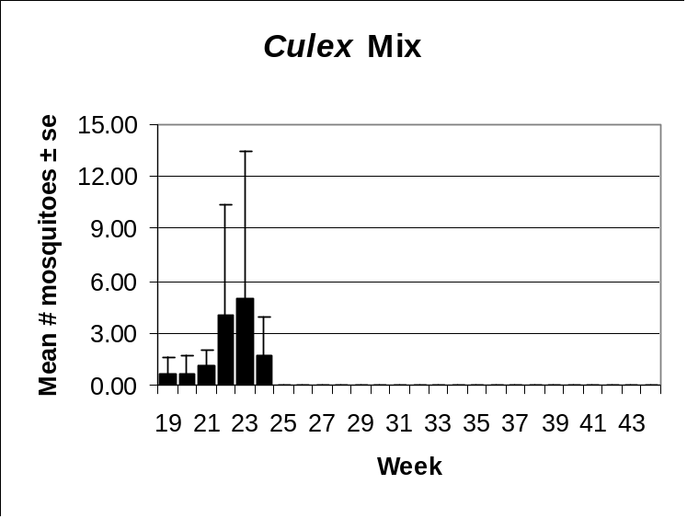
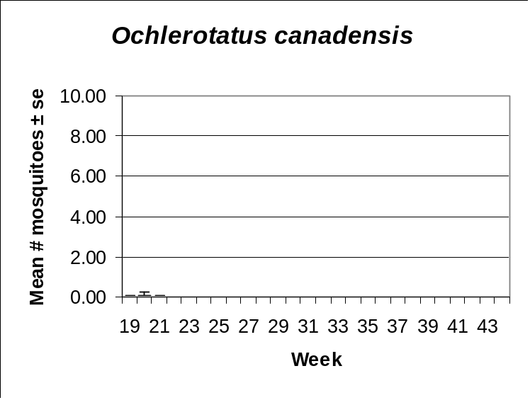

Pinelands
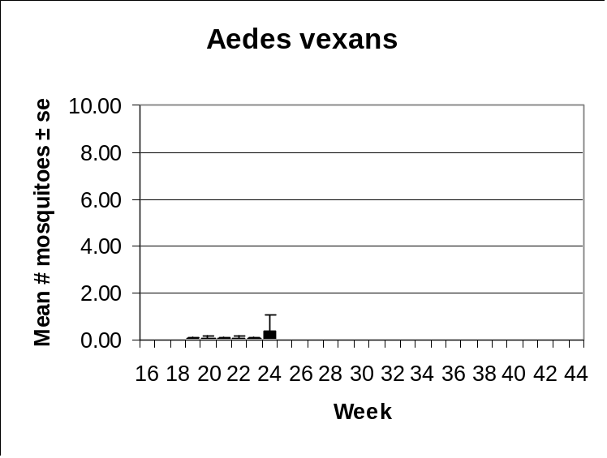 | 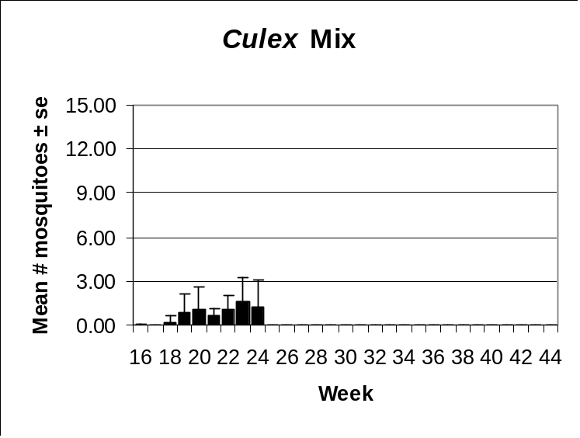
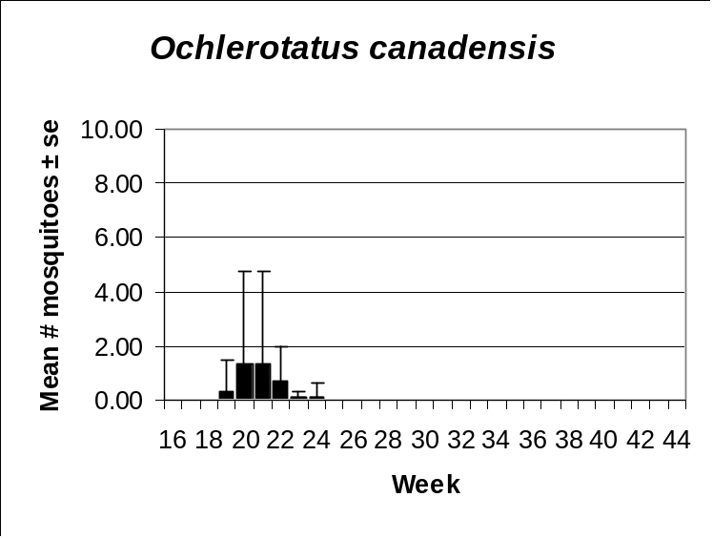 | 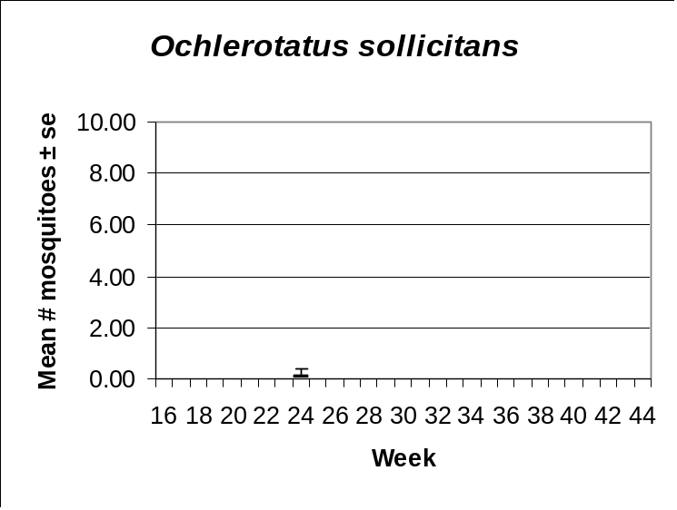

Suburban Corridor
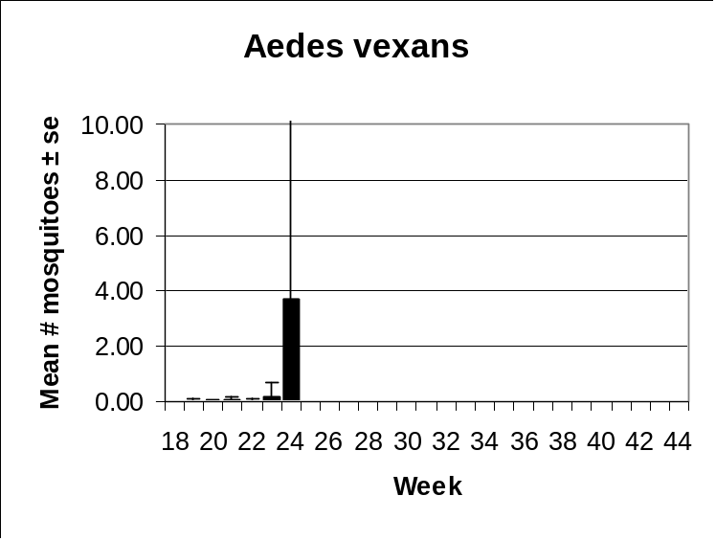 | 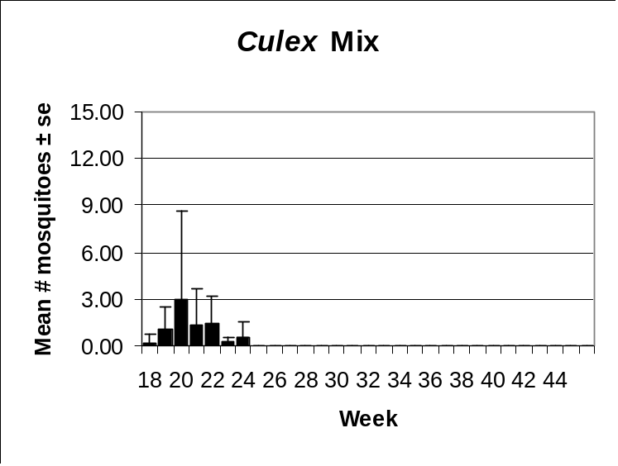
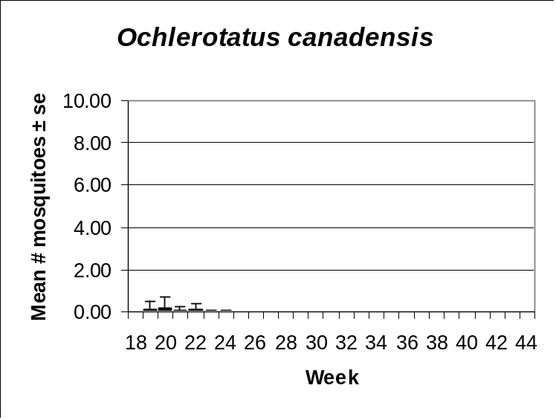 | 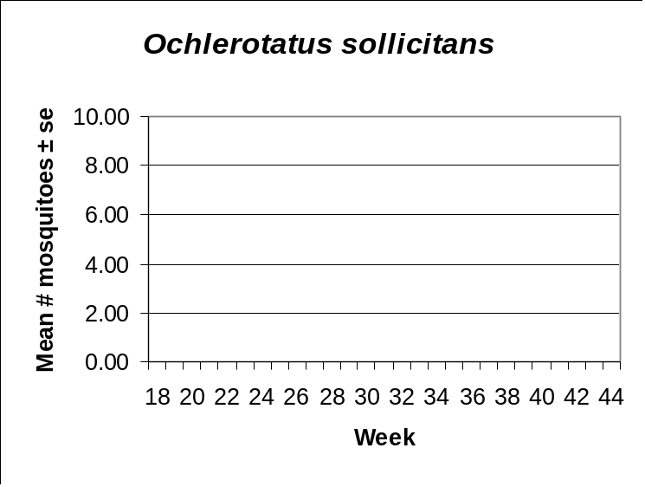

Aedes vexans
Agricultural | Coastal | Delaware Bayshore | Delaware River Basin
New York Metro | North Central Rural | Northwestern Rural | Philadelphia Metro
Pinelands | Suburban Corridor | Comments
 |  | Aedes vexans is a floodwater mosquito that relies on heavy rains to produce repeated broods during the summer months. Temperatures for the Month of May were lower than normal and rainfall was continuous, allowing little opportunity for dry down and egg conditioning. State surveillance data indicate that a major emergence occurred in Week 24. The highest populations occurred in the Delaware River Basin region, where dredge spoils provide chronic Ae. vexans problems. Sizeable broods were also documented in the Agricultural, Coastal, and Suburban Corridor regions.

Culex Complex
Agricultural | Coastal | Delaware Bayshore | Delaware River Basin
New York Metro | North Central Rural | Northwestern Rural | Philadelphia Metro
Pinelands | Suburban Corridor | Comments
 |  | Members of the Culex complex normally increase steadily as the season progresses because the group relies on permanent water and overlapping generations. Sharp depressions in this general pattern are often an indication of control intervention. Culex from the Delaware Bayshore, Delaware River Basin, and Coastal regions are probably Cx. salinarius. Culex populations from the two metropolitan areas are primarily Cx pipiens/restuans. Cx. restuans has the ability to breed in standing ground water left over from woodland pools that do not dry completely. This likely explains the high Culex populations in the Agricultural and Pineland regions, areas that are not normally associated with this group..

Ochlerotatus canadensis
Agricultural | Coastal | Delaware Bayshore | Delaware River Basin
New York Metro | North Central Rural | Northwestern Rural | Philadelphia Metro
Pinelands | Suburban Corridor | Comments
 |  | Oc. canadensis is an early season pest that reaches highest numbers in early spring. This year’s dataset shows exceptionally low population levels considering the amount of rain New Jersey experienced this spring. This is probably due to missing data points from key counties in the northern half of the state. A clearer picture of Oc. canadensis population dynamics will not be known until the dataset is complete.

Ochlerotatus sollicitans
Agricultural | Coastal | Delaware Bayshore | Delaware River Basin
New York Metro | North Central Rural | Northwestern Rural | Philadelphia Metro
Pinelands | Suburban Corridor | Comments
 |  | Oc. sollicitans populations do not normally peak until June or July when warm water temperatures stimulate extensive egg hatch. This species relies heavily on lunar tides that flood areas of high salt marsh where the species oviposits. Data from the State Surveillance light traps indicate that a minor emergence took place in the three coastal regions that provide habitat during Week 24. Significantly larger broods can be expected from this point on in the season.

Other Species - Ochlerotatus cantator
Agricultural | Coastal | Delaware Bayshore | Delaware River Basin
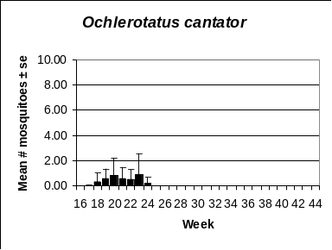 | 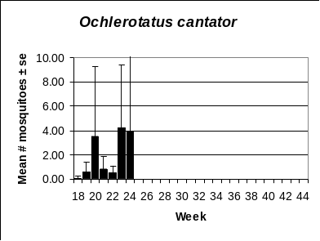 | 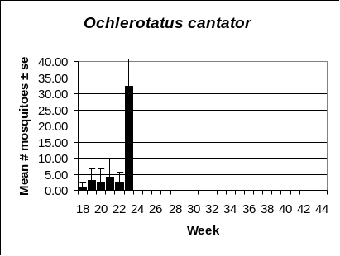 | 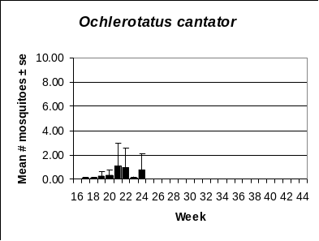
New York Metro | North Central Rural | Northwestern Rural | Philadelphia Metro
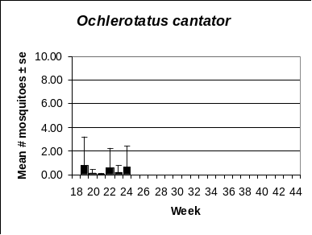 | 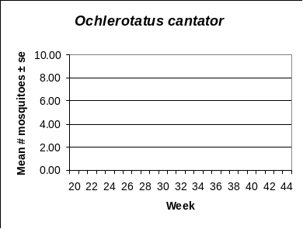 | 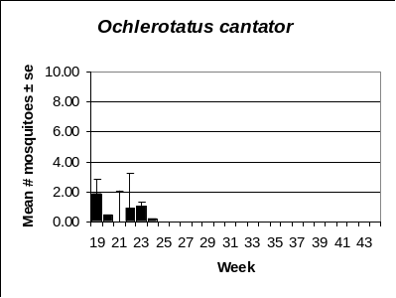 | 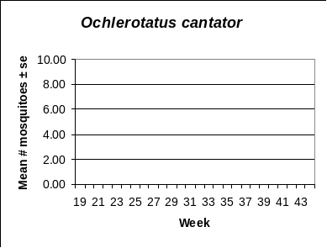
Pinelands | Suburban Corridor | Comments
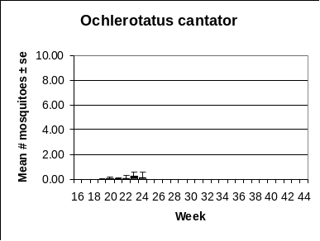 | 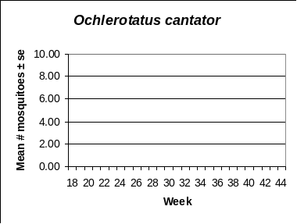 | Oc. cantator is an early season saltmarsh mosquito that is replaced by Oc. sollicitans as the season advances. Relic populations are also found in rural areas where salt-based industrial wastes provide isolated pockets of suitable habitat. The three coastal regions that provide suitable habitat produced Oc. cantator during most of the Month of May. An extensive emergence took place during Week 24 in the Delaware Bayshore region, where populations exceeded 30 mosquitoes per trap night.

