NEW JERSEY STATE SURVEILLANCE

Weekly Report for Week 26, 22 June – 29 June, 2003

Submitted by Lisa Reed and Wayne Crans

Mosquito Research and Control Unit

Rutgers University, New Brunswick, NJ 08901
Figure 1a: Map of ten regions selected for the New Jersey Surveillance Program overlaid with county boarders. |  | Figure 1b. Trap lat-long locations.
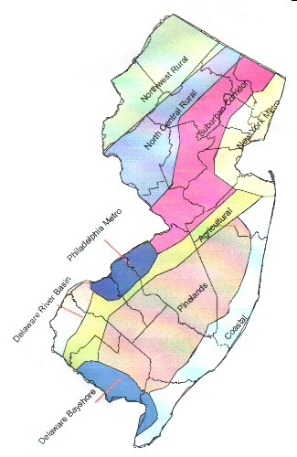 |  | 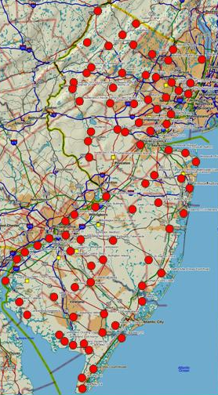
Preface: Data from 84 New Jersey light traps from all 21 counties are used to calculate trends in mosquito populations for species of nuisance or health concerns. Calculations are based on regional distributions, with emphasis on mosquito habitat and land use. Trends will allow a statewide evaluation of changing mosquito populations, in response to control and/or changes in habitat.
This is New Jersey Agricultural Experiment Station publication No. PT-40500-26-03 supported by Hatch funds and funding from the NJ State Mosquito Control Commission. Prepared by Lisa M. Reed and Wayne J. Crans.

Summary table
 | Aedes vexans |  | Culex complex |  | Ochlerotatus canadensis |  | Ochlerotatus sollicitans
Region | This Week | Average* | This Week | Average* | This Week | Average* | This Week | Average*
Agricultural | 1.10 |  | 0.76 |  | 0.00 |  | 0.00
Coastal | 0.00 |  | 0.00 |  | 0.00 |  | 0.00
Delaware Bayshore | 0.00 |  | 0.00 |  | 0.00 |  | 0.00
Delaware River Basin | 0.00 |  | 0.00 |  | 0.00 |  | 0.00
New York Metro | 8.05 |  | 6.37 |  | 0.01 |  | 0.00
North Central Rural | 1.53 |  | 4.41 |  | 0.04 |  | 0.00
Northwest Rural | 2.55 |  | 3.98 |  | 0.07 |  | 0.00
Philadelphia Metro | 19.98 |  | 3.43 |  | 0.00 |  | 0.00
Pinelands | 0.13 |  | 0.57 |  | 0.05 |  | 0.00
Suburban Corridor | 17.66 |  | 6.16 |  | 1.25 |  | 0.10

- Complete data not yet available.

Agricultural
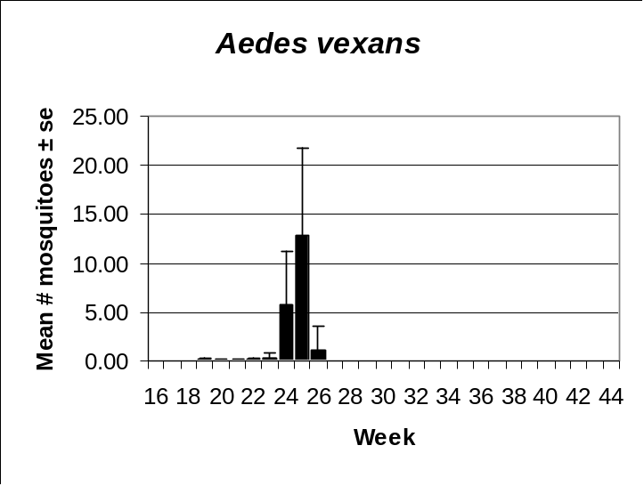 | 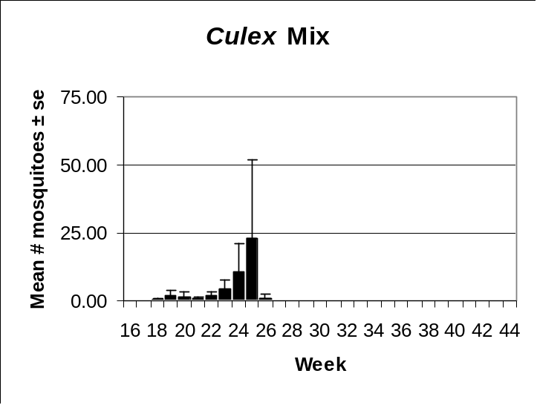
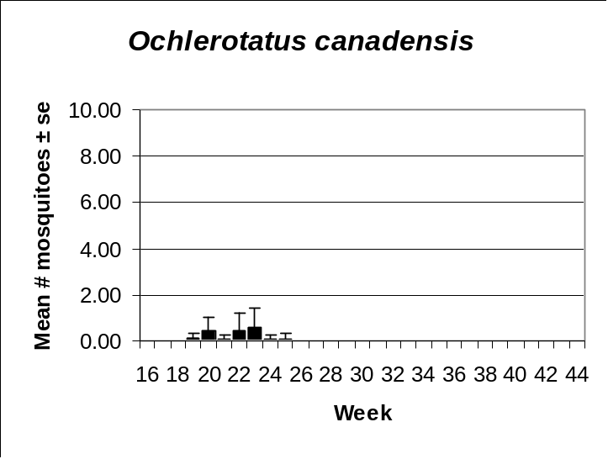 | 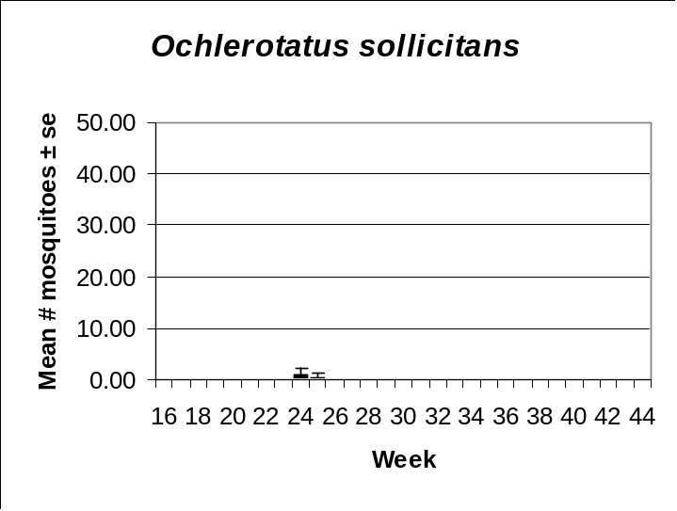

Coastal
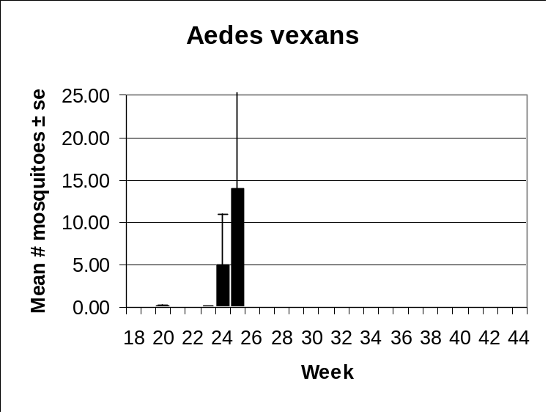 | 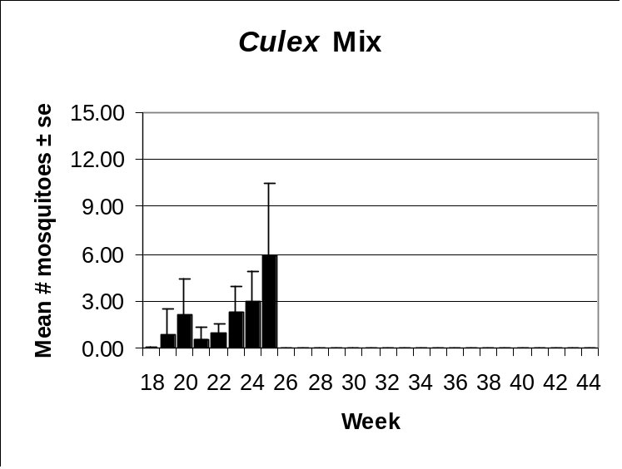
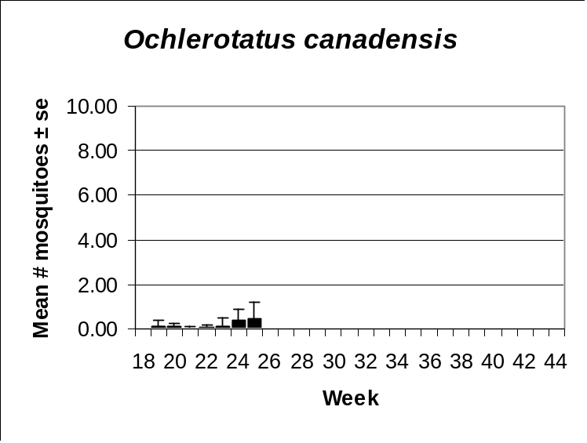 | 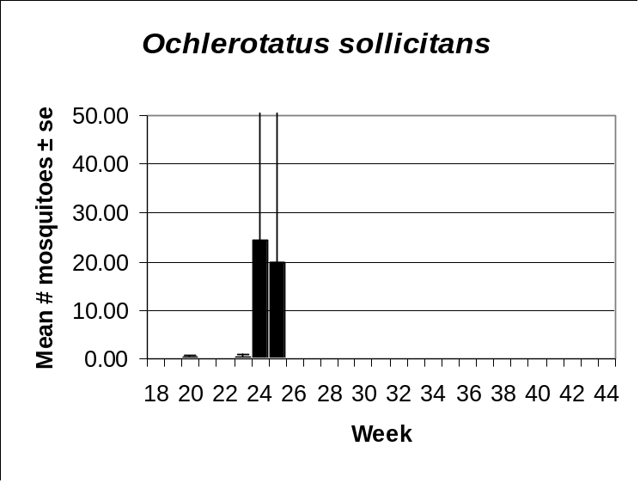

Delaware Bayshore
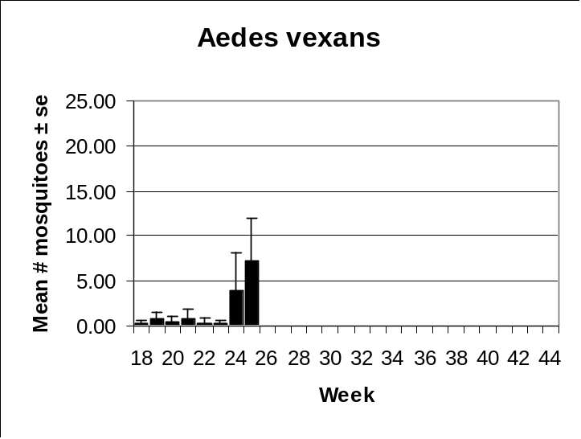 | 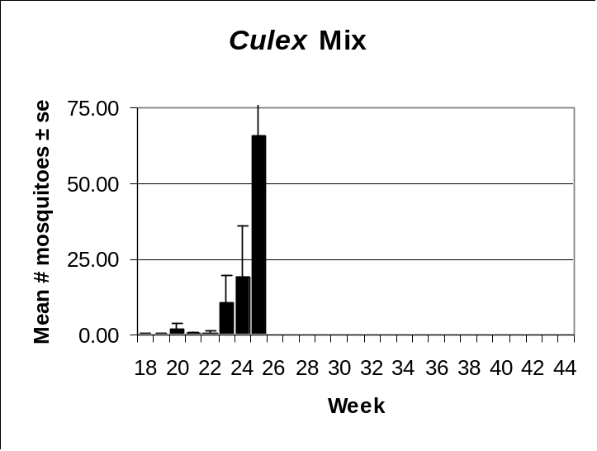
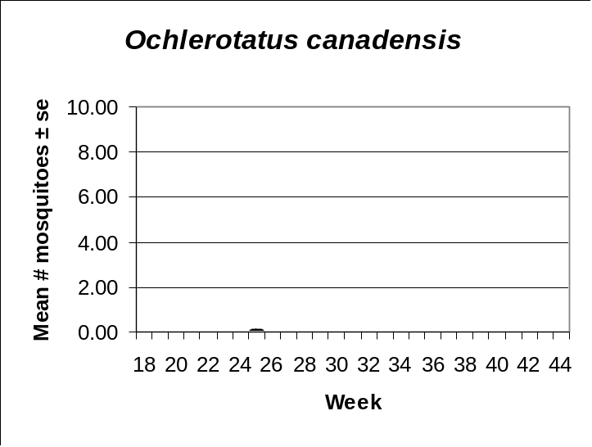 | 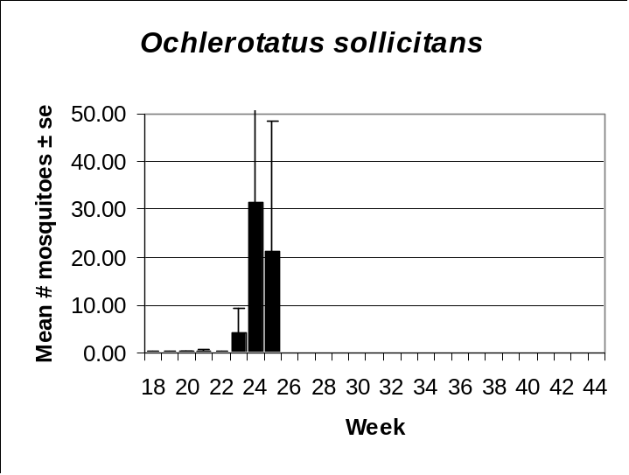

Delaware River Basin
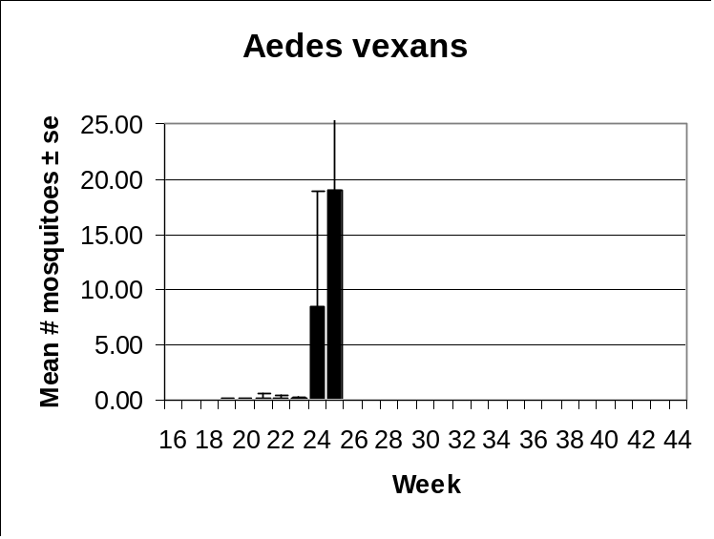 | 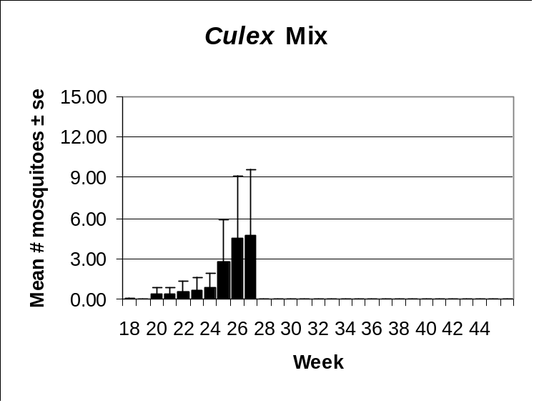
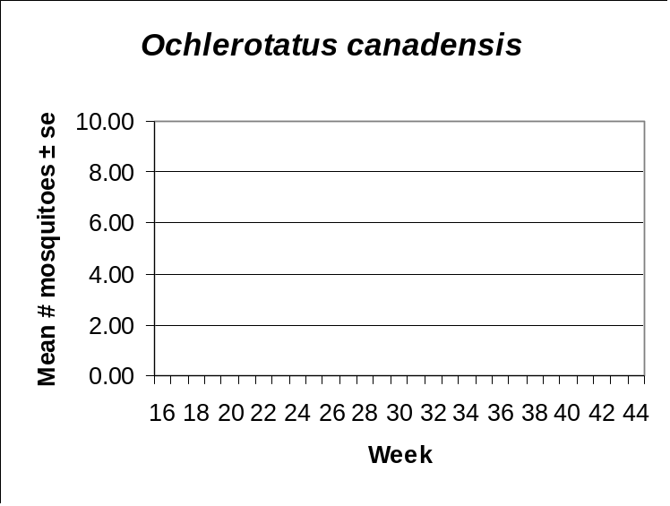 | 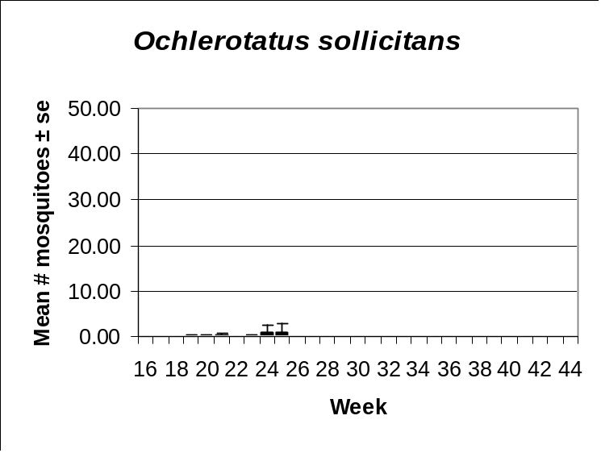

New York Metro
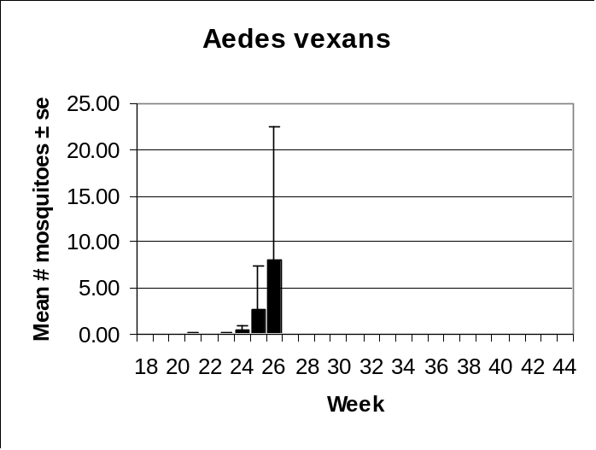 | 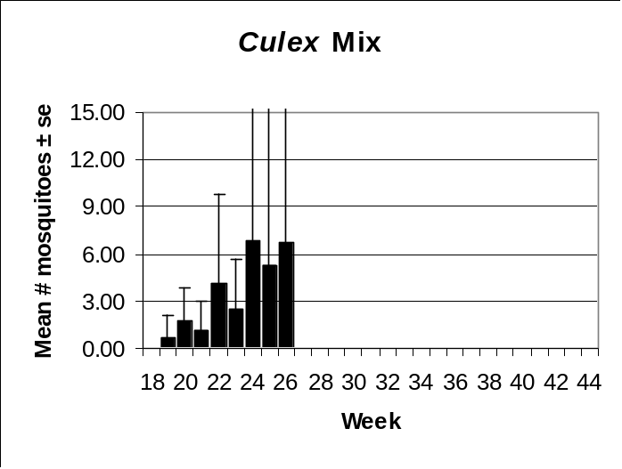
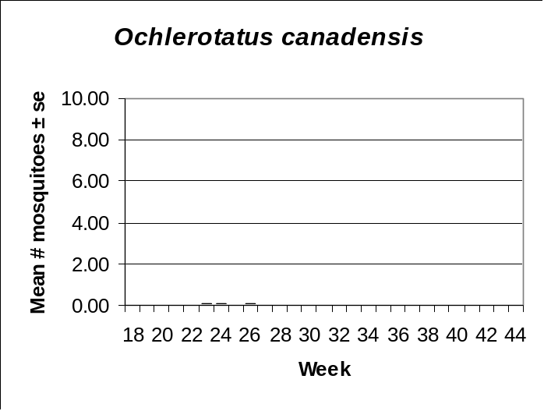 | 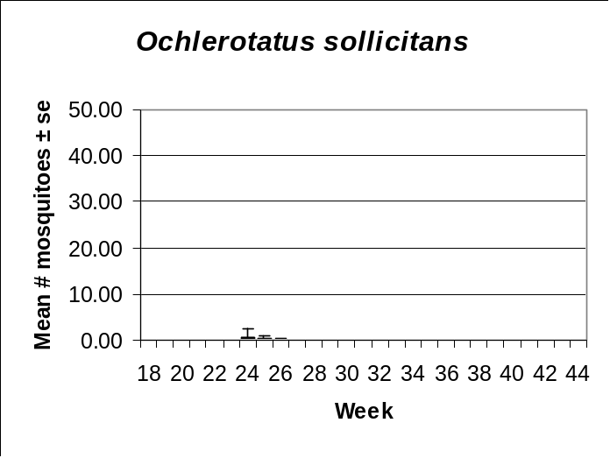

North Central Rural
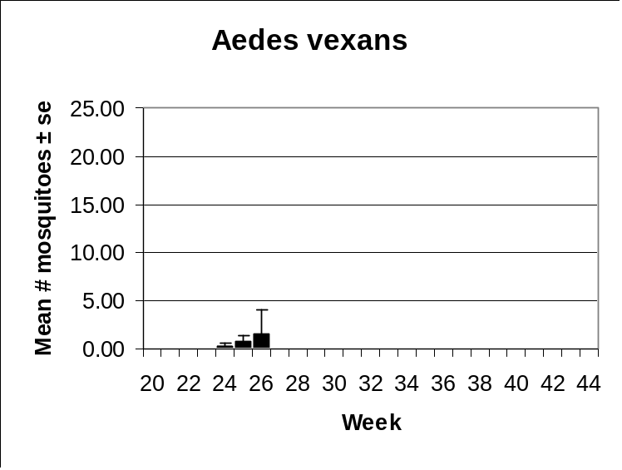 | 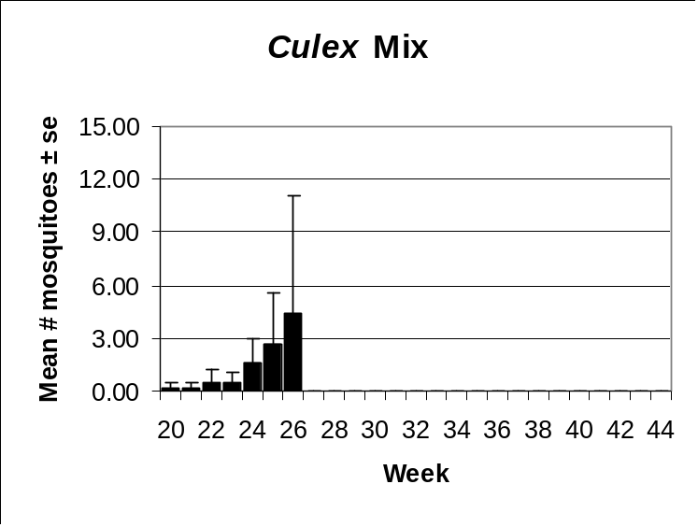
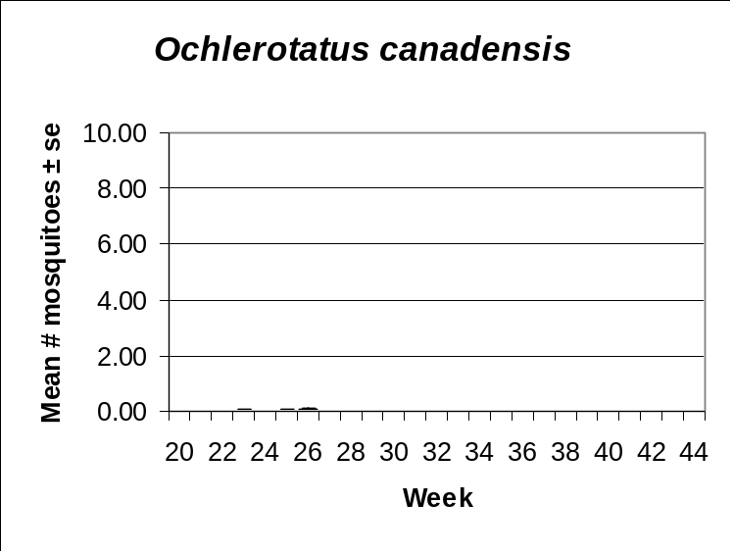 | 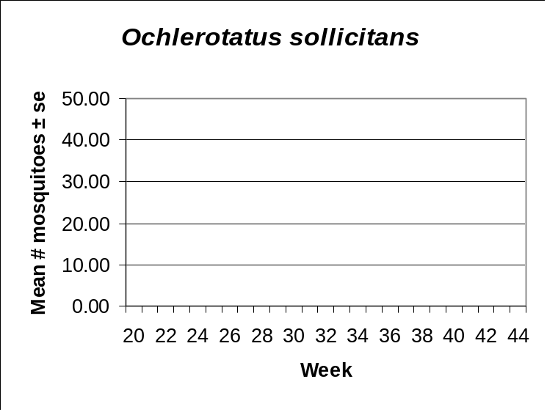

Northwestern Rural
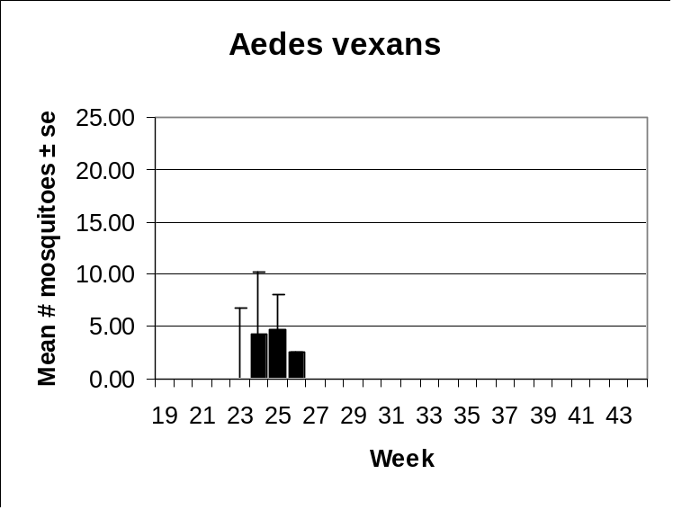 | 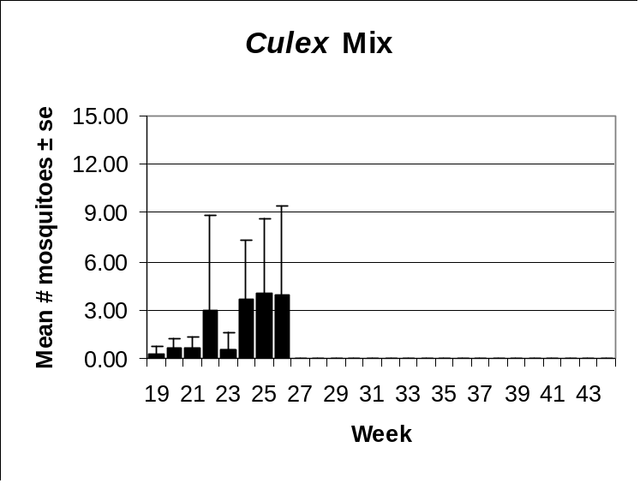
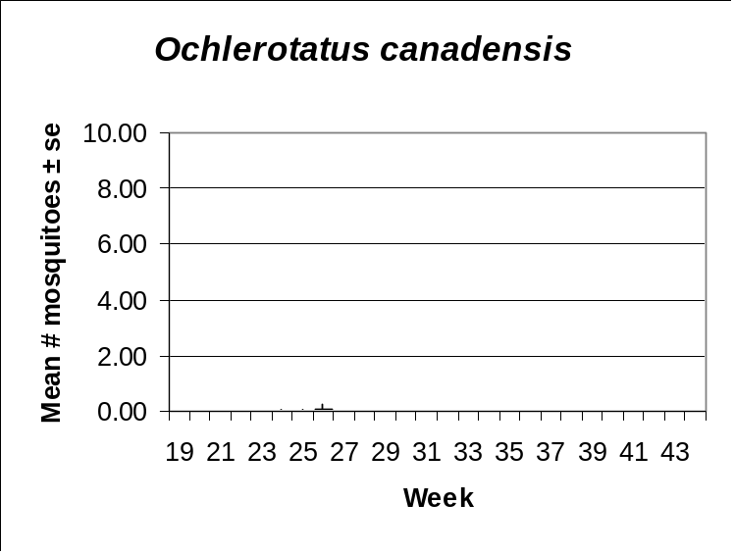 | 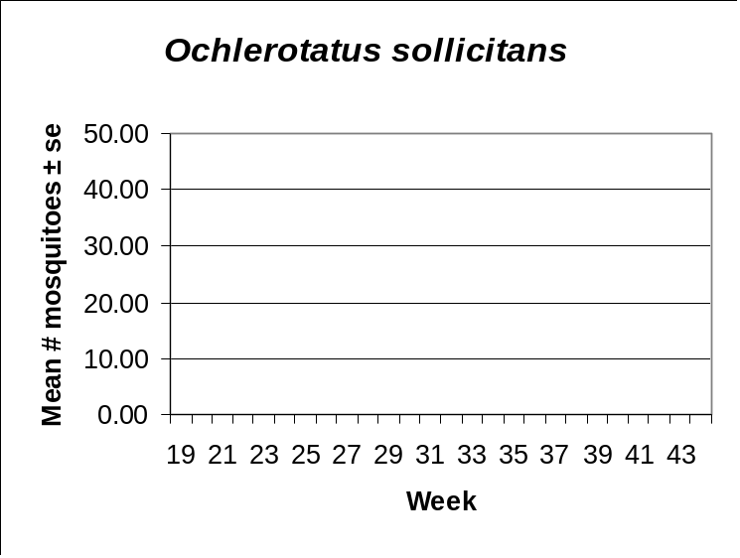

Philadelphia Metro
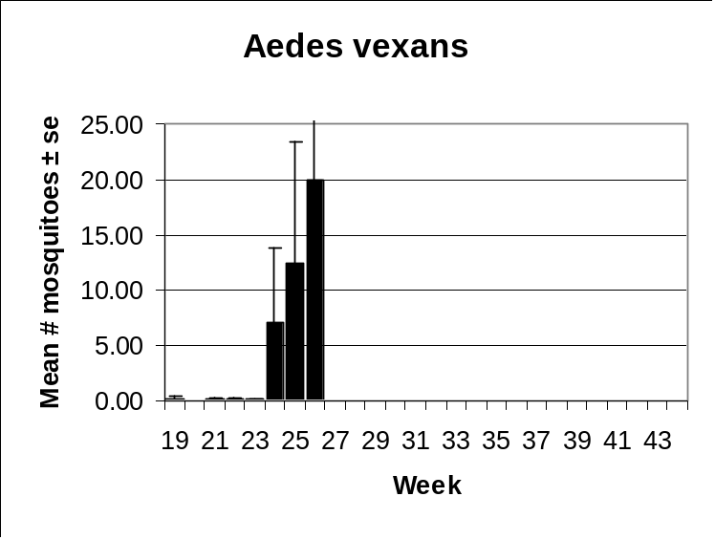 | 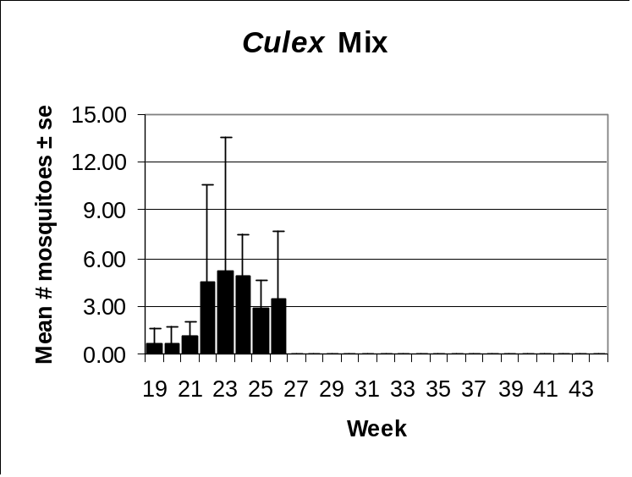
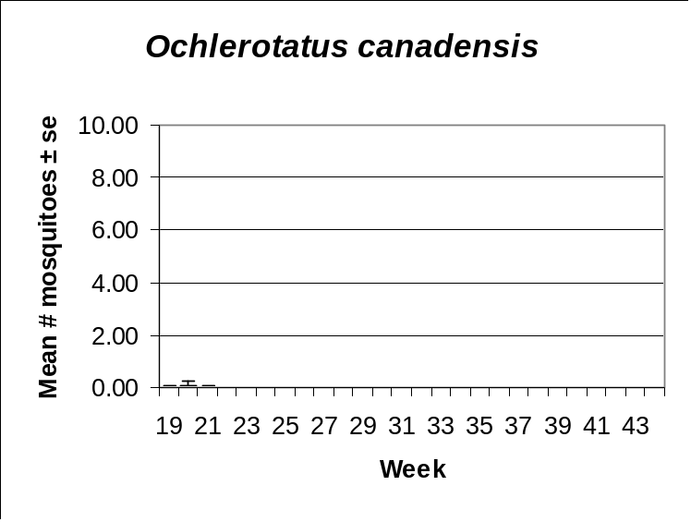

Pinelands
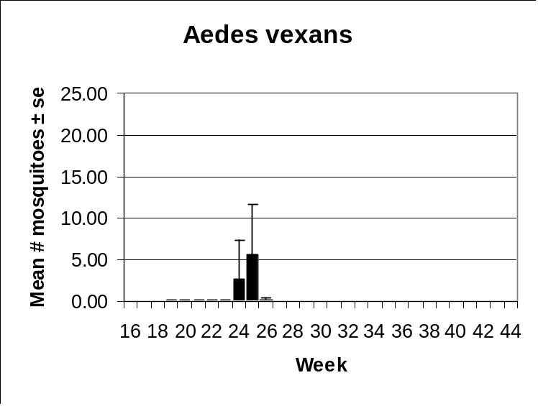 | 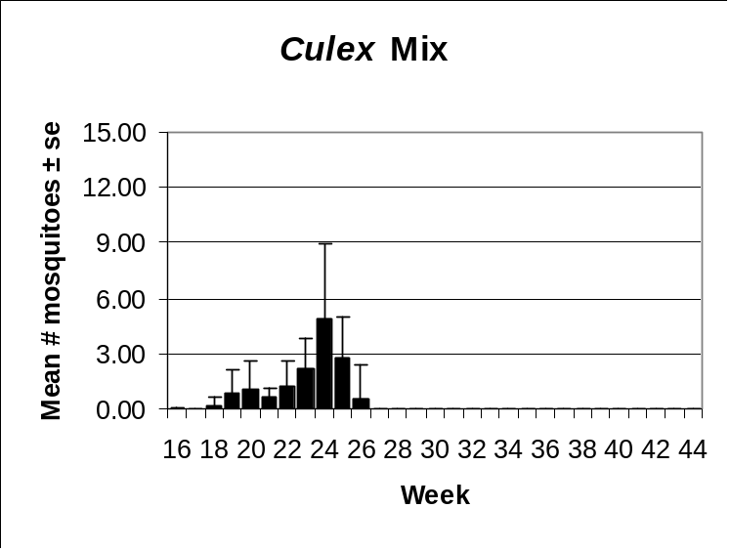
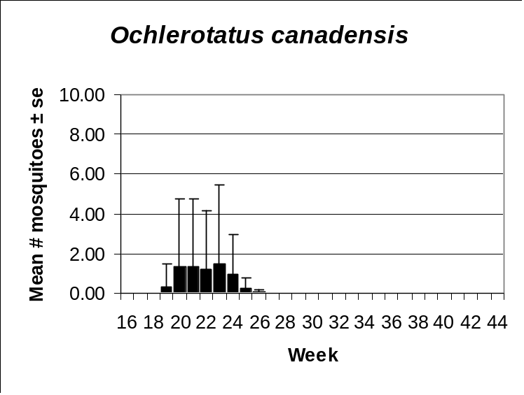 | 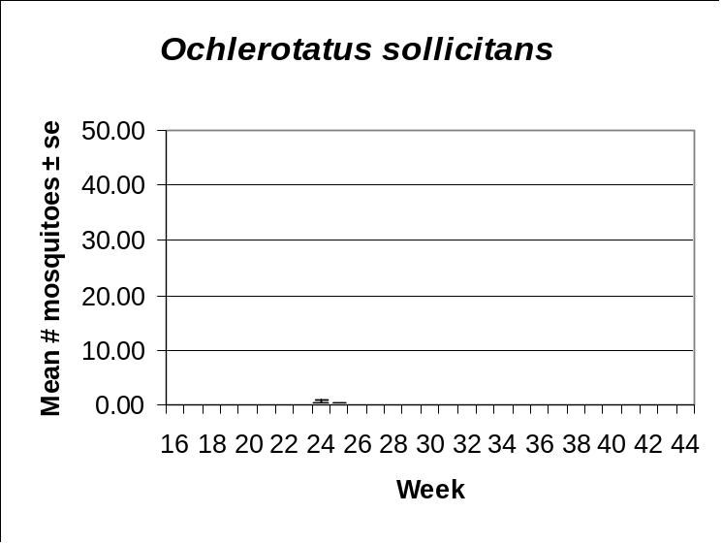

Suburban Corridor
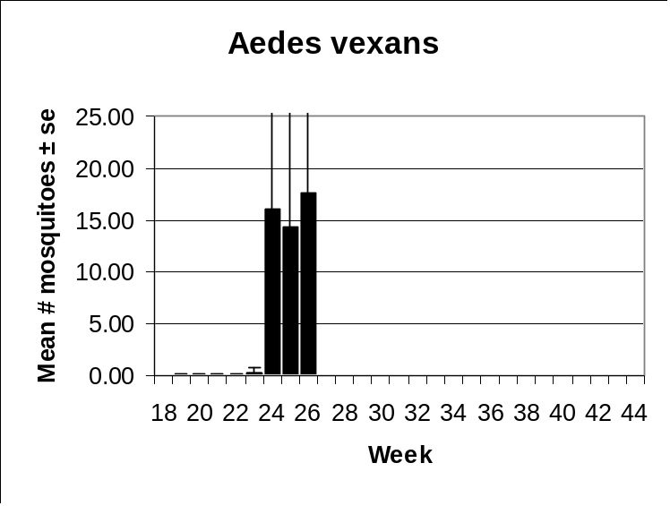 | 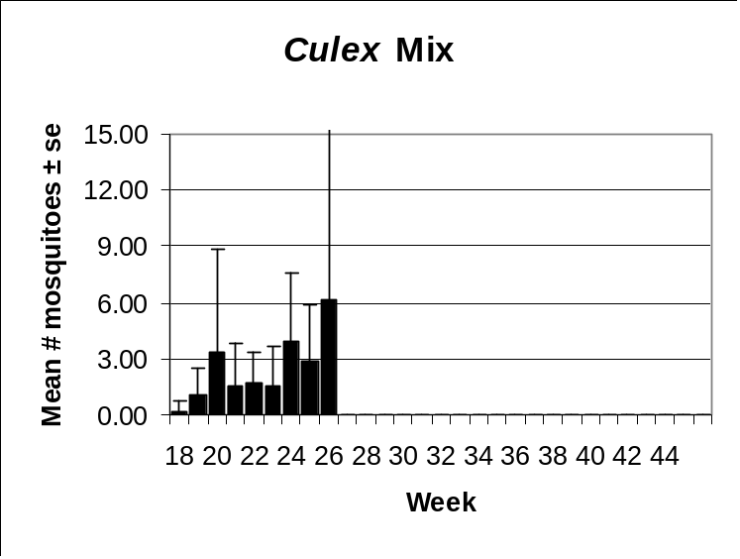
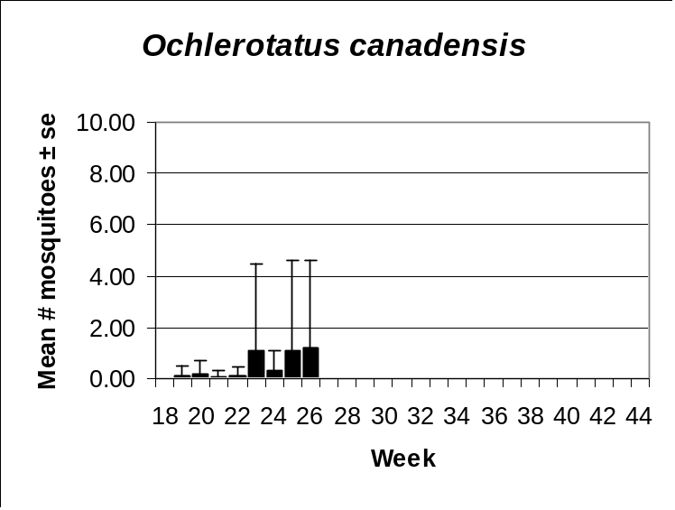 | 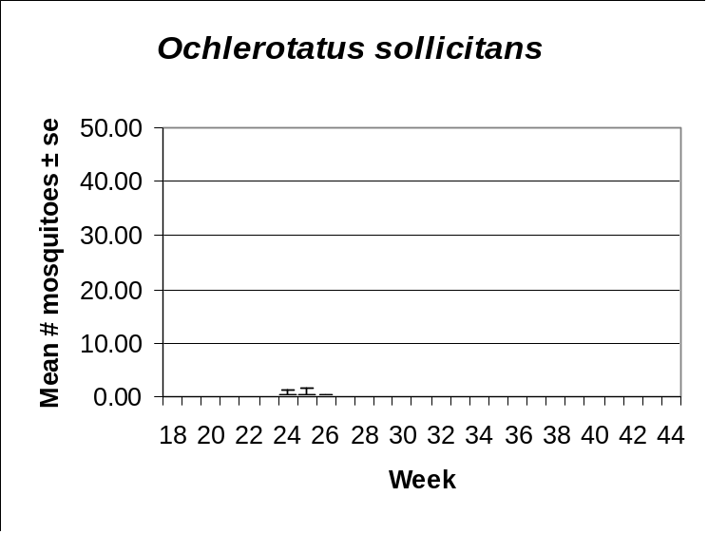

Aedes vexans
Agricultural | Coastal | Delaware Bayshore | Delaware River Basin
New York Metro | North Central Rural | Northwestern Rural | Philadelphia Metro
Pinelands | Suburban Corridor | Comments
 |  | State Surveillance light trap data clearly show that the extensive rains NJ experienced in early June has produced a major brood of floodwater mosquitoes. Aedes vexans populations were first noted to be on the increase during week 24. Current data show a rising trend with a probable peak in week 26. Light trap numbers approached 20 per trap night in much of southern NJ. Populations were lowest in the Northwestern Rural, North Central Rural & Pinelands regions.

Culex Complex
Agricultural | Coastal | Delaware Bayshore | Delaware River Basin
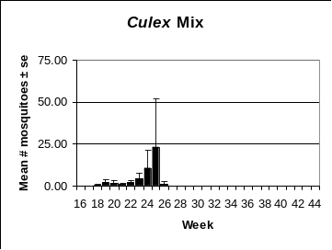 | 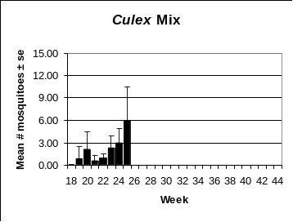 | 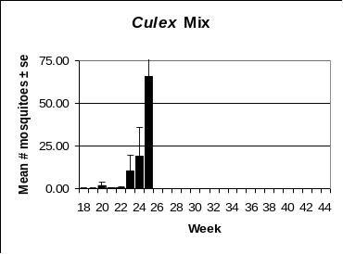 | 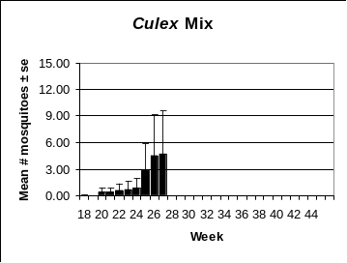
New York Metro | North Central Rural | Northwestern Rural | Philadelphia Metro
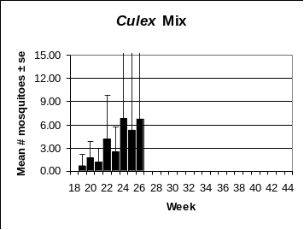 | 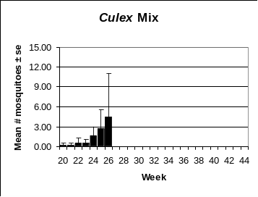 | 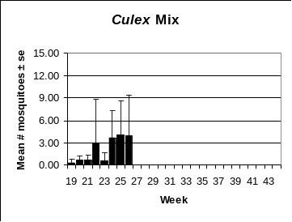 | 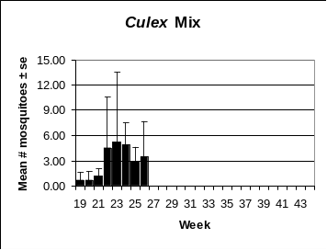
Pinelands | Suburban Corridor | Comments
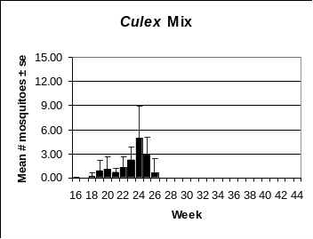 | 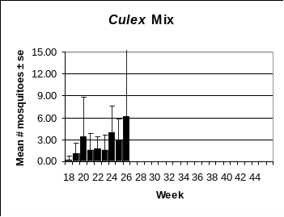 | Culex populations continue an upward trend in most of the regions this program is monitoring. The numbers from the Delaware Bayshore region approached 75 mosquitoes per trap night, in all probability primarily Cx. salinarius.. This is the time when Culex control practices should be accelerated to minimize WNV amplification. The general public should also be reminded to police their own properties and eliminate container habitat whenever possible.

Ochlerotatus canadensis
Agricultural | Coastal | Delaware Bayshore | Delaware River Basin
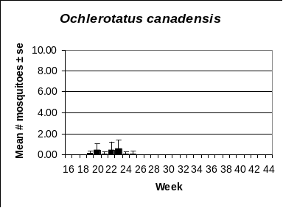 | 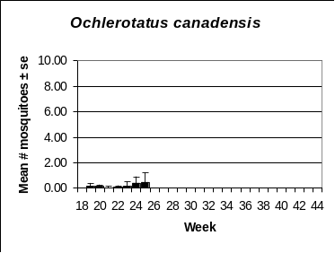 | 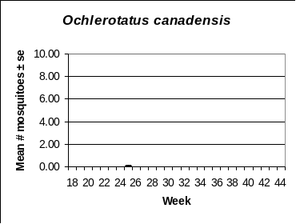 | 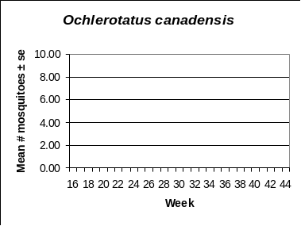
New York Metro | North Central Rural | Northwestern Rural | Philadelphia Metro
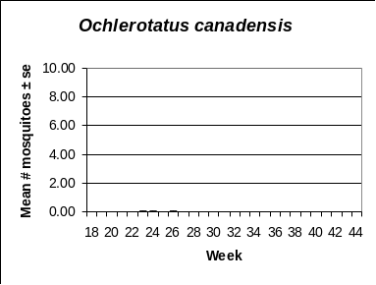 | 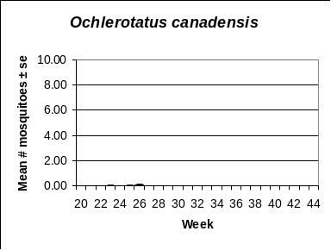 | 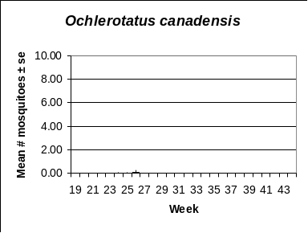 | 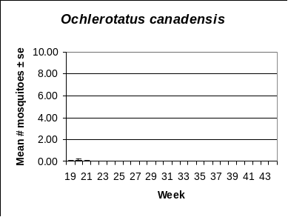
Pinelands | Suburban Corridor | Comments
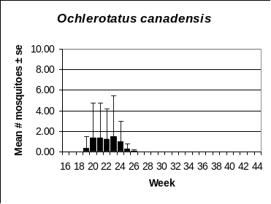 | 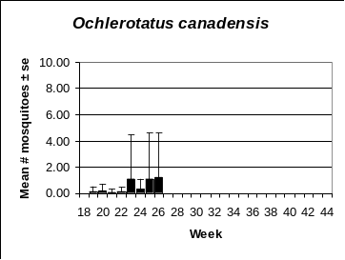 | The heavy rainfall NJ experienced during the month of June did not increase Oc. canadensis populations significantly. Light trap counts remain below 1 mosquito per trap night in virtually all of the regions being monitored by this program. Nuisance from Oc. canadensis will be minimal for most of the remaining part of this year’s mosquito season. Late summer rains could allow the species to reappear in some areas to produce late season annoyance.

Ochlerotatus sollicitans
Agricultural | Coastal | Delaware Bayshore | Delaware River Basin
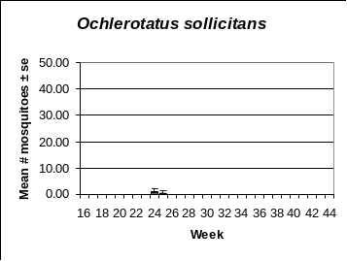 | 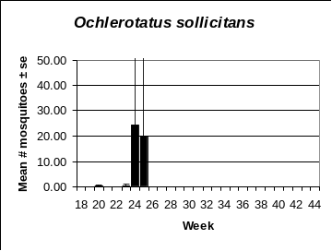 | 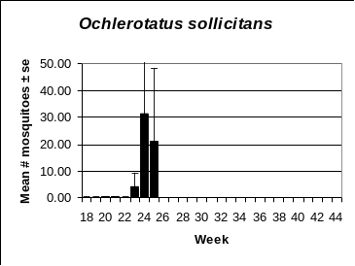 | 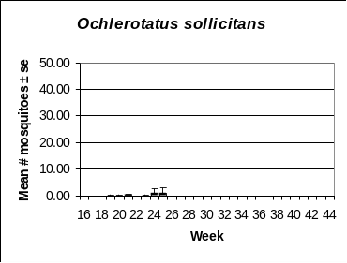
New York Metro | North Central Rural | Northwestern Rural | Philadelphia Metro
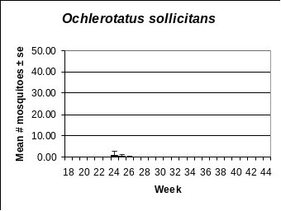 | 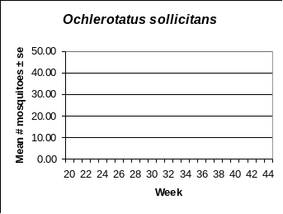 | 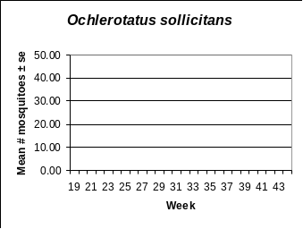 | 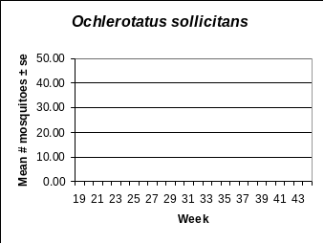
Pinelands | Suburban Corridor | Comments
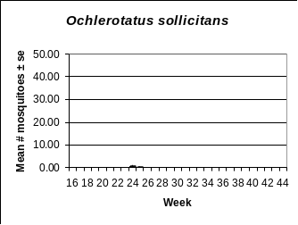 | 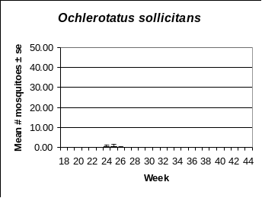 | Light trap data show that Oc. sollicitans has, thus far, been limited to coastal regions that provide most of its breeding habitat. Exceptionally large broods often move far enough inland to show up in other areas of the state. Light trap records show that the 1st brood of the season peaked between 20 and 30 mosquitoes per trap night on the Atlantic coast and Delaware Bay. Small numbers have appeared in the New York Metro, Pinelands and Suburban Corridor regions but it is unlikely that the migrants occur in high enough numbers to cause nuisance.

Other Species – Coquillettidia perturbans
Agricultural | Coastal | Delaware Bayshore | Delaware River Basin
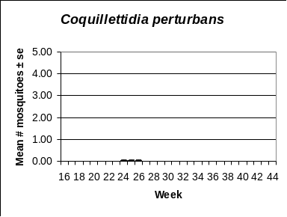 | 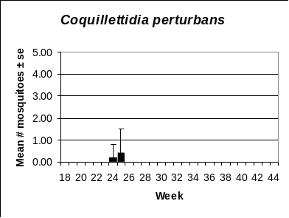 | 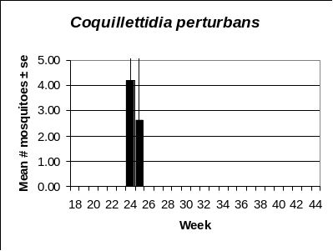 | 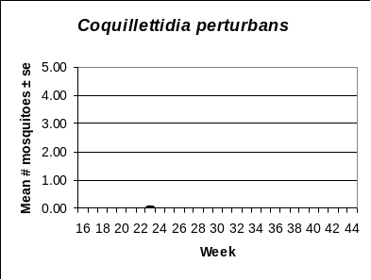
New York Metro | North Central Rural | Northwestern Rural | Philadelphia Metro
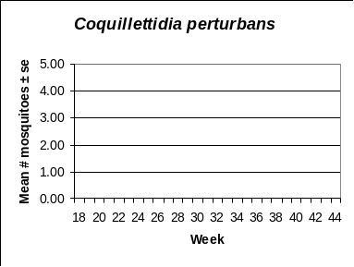 | 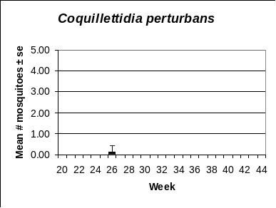 | 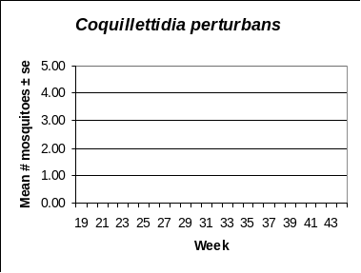 | 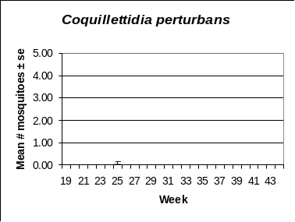
Pinelands | Suburban Corridor | Comments
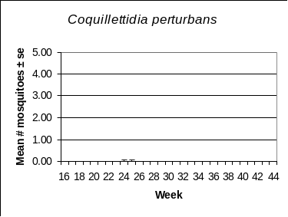 | 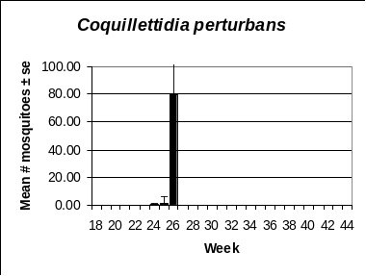 | State Surveillance light trap data indicate that the 1st cohort of Cq. perturbans emerged in some parts of NJ. Cq. perturbans takes a full year to complete its life cycle and the species overwinters as a combination of 2nd, 3rd & 4th larval instars. The various instars emerge as cohorts the following year giving the appearance of 3 distinct broods. The composition of the overwintering larval population determines the size and timing of the summer emergences. Light trap records from Mercer Co. recorded the largest wave from the 1st cohort with nearly 80 mosquitoes per trap night. The cohort that emerged in the Delaware Bay region was significantly smaller averaging less than 5 mosquitoes per trap night. How the 1st cohort will compare with those that follow cannot be predicted without knowledge of the proportion of larval instars in last winter’s overwintering population.

Top Ten species per Region
Agricultural | Coastal
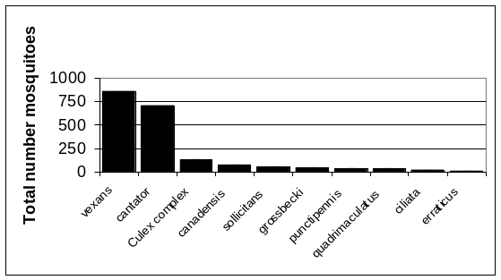 | 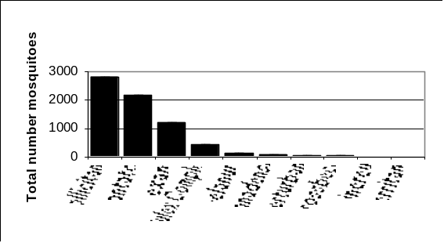
Delaware Bayshore | Delaware River Basin
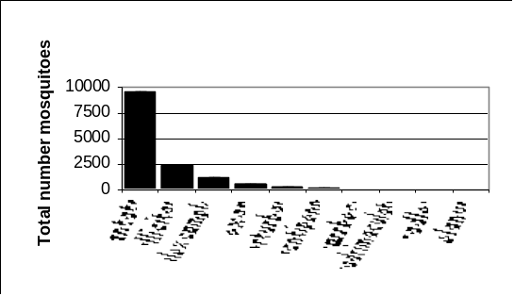 | 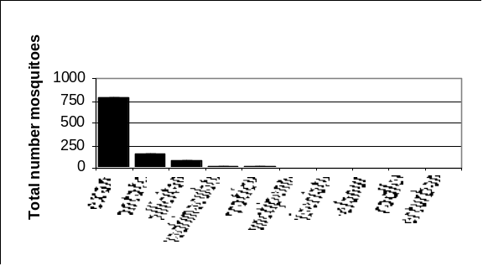
New York Metro | North Central Rural
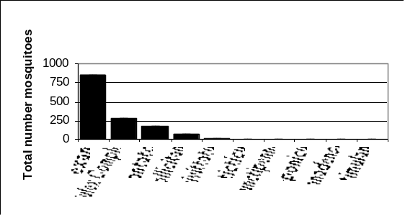 | 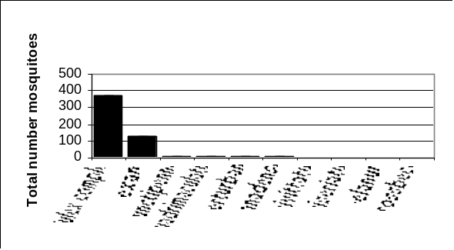
Northwestern Rural | Philadelphia Metro
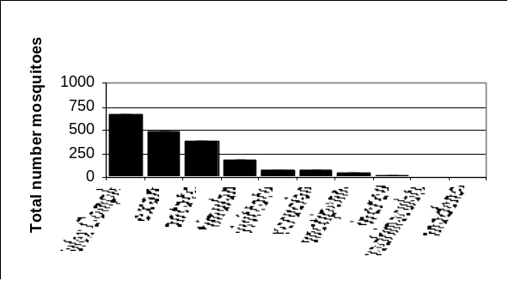 | 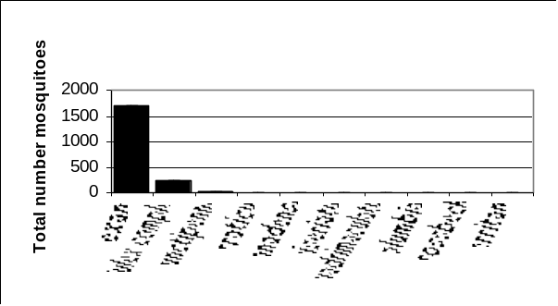
Pinelands | Suburban Corridor
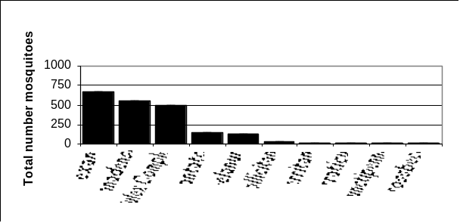 | 

