NEW JERSEY STATE SURVEILLANCE
Weekly Report for Week 23, 1 June – 7 June, 2003

Submitted by Wayne Crans and Lisa Reed
Mosquito Research and Control Unit
Rutgers University, New Brunswick, NJ 08901

Figure 1a: Map of ten regions selected for the New Jersey Surveillance Program overlaid with county boarders. |  | Figure 1b. Trap lat-long locations.
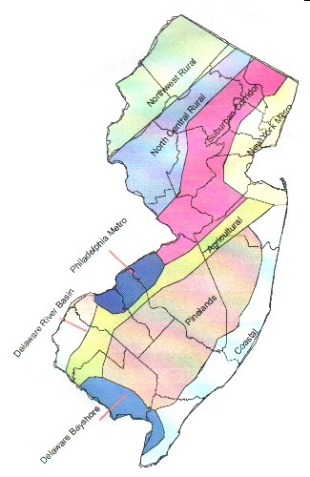 |  | 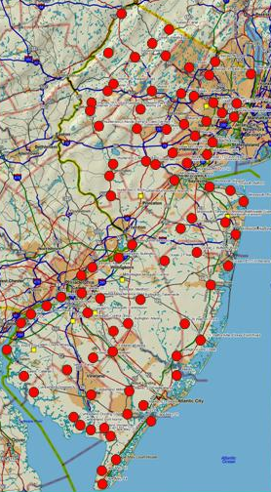
Preface: Data from 84 New Jersey light traps from all 21 counties are used to calculate trends in mosquito populations for species of nuisance or health concerns. Calculations are based on regional distributions, with emphasis on mosquito habitat and land use. Trends will allow a statewide evaluation of changing mosquito populations, in response to control and/or changes in habitat.

Summary table

 | Aedes vexans |  | Culex complex |  | Ochlerotatus canadensis |  | Ochlerotatus sollicitans
Region | This Week | Average* | This Week | Average* | This Week | Average* | This Week | Average*
Agricultural | 0.17 |  | 2.80 |  | 0.00 |  | 0.00
Coastal | 0.02 |  | 0.46 |  | 0.13 |  | 0.11
Delaware Bayshore | 0.17 |  | 7.98 |  | 0.00 |  | 0.79
Delaware River Basin | 0.00 |  | 1.96 |  | 0.00 |  | 0.04
New York Metro | 0.05 |  | 1.84 |  | 0.00 |  | 0.03
North Central Rural | 0.00 |  | 0.02 |  | 0.00 |  | 0.00
Northwest Rural | 0.00 |  | 0.19 |  | 0.00 |  | 0.00
Philadelphia Metro | 0.00 |  | 0.00 |  | 0.00 |  | 0.00
Pinelands | 0.01 |  | 0.92 |  | 0.08 |  | 0.00
Suburban Corridor | 0.01 |  | 0.14 |  | 0.01 |  | 0.00

* Complete data not yet available.

This is Jersey Agricultural Experiment Station publication No. PT-40500-23-03, supported by Hatch funds and funding from the NJ State Mosquito Control Commission. Summary prepared by: Lisa Reed and Wayne Crans.

Agricultural
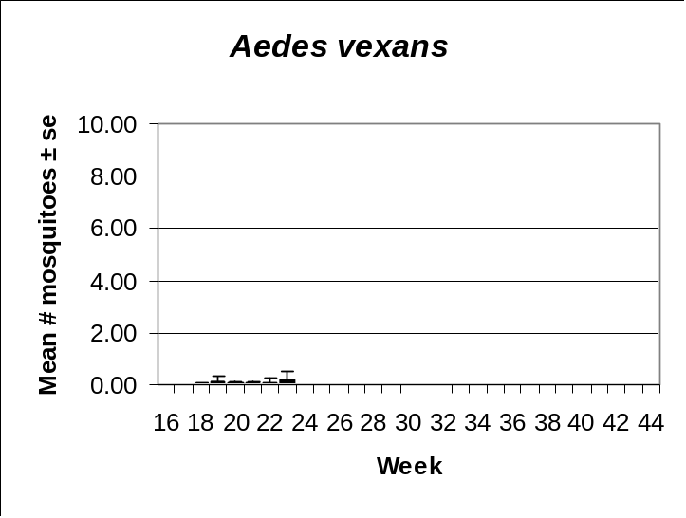 | 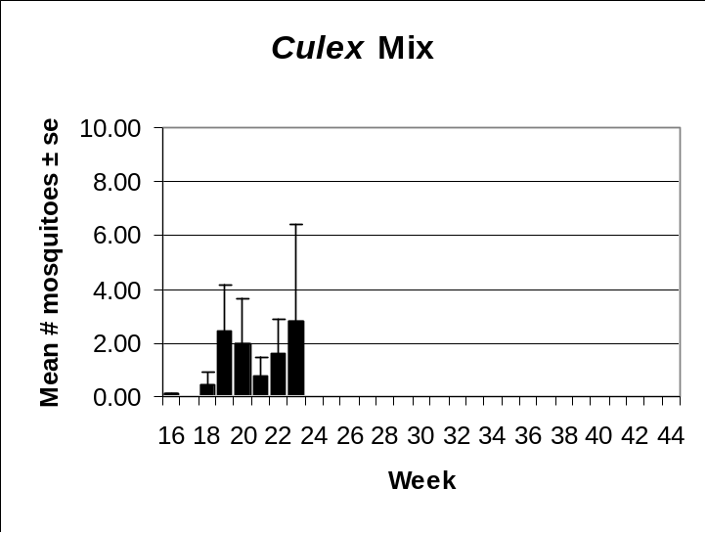
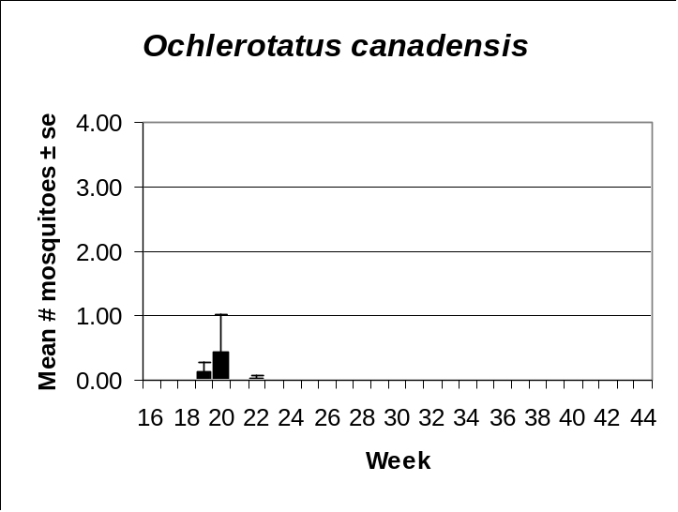 | 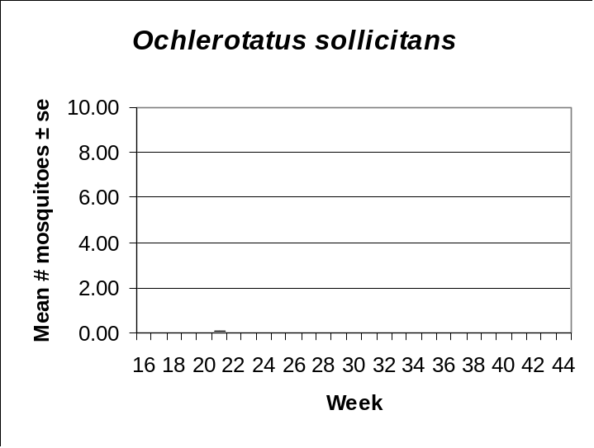

Coastal
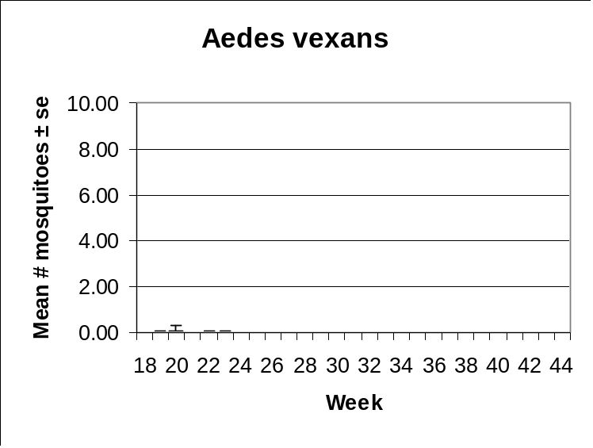 | 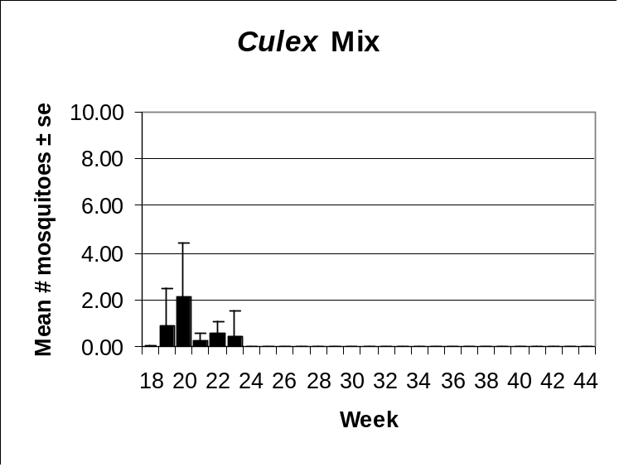
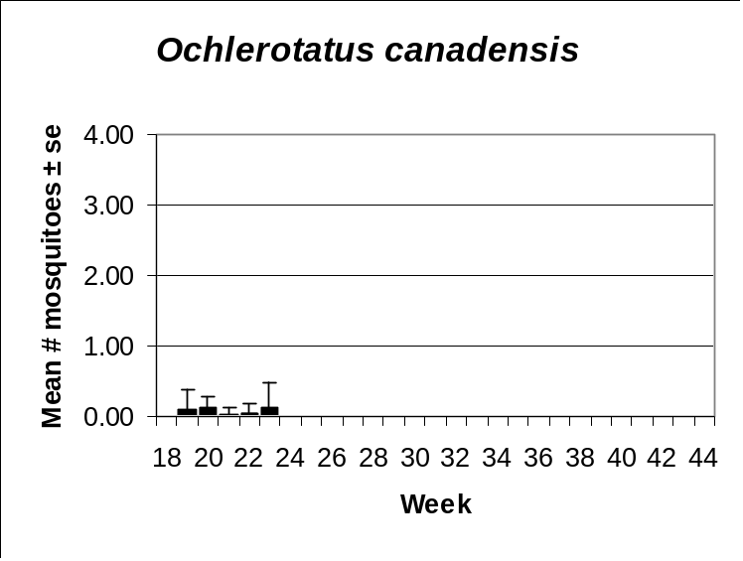 | 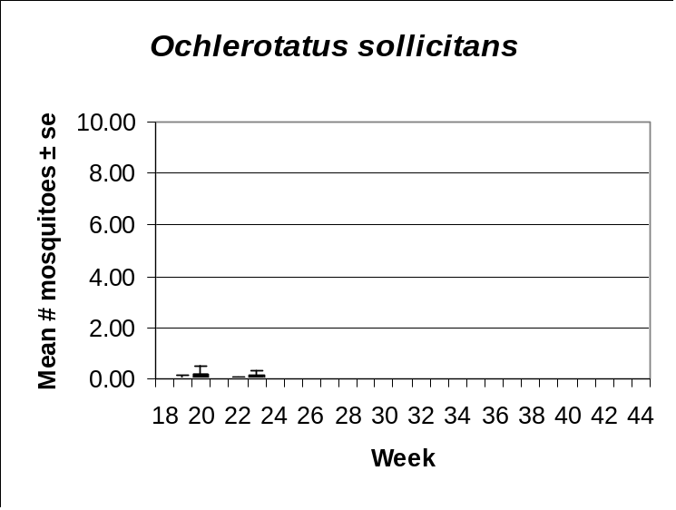

Delaware Bayshore
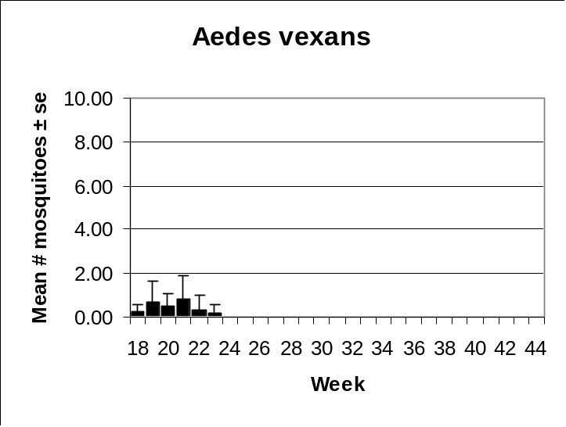 | 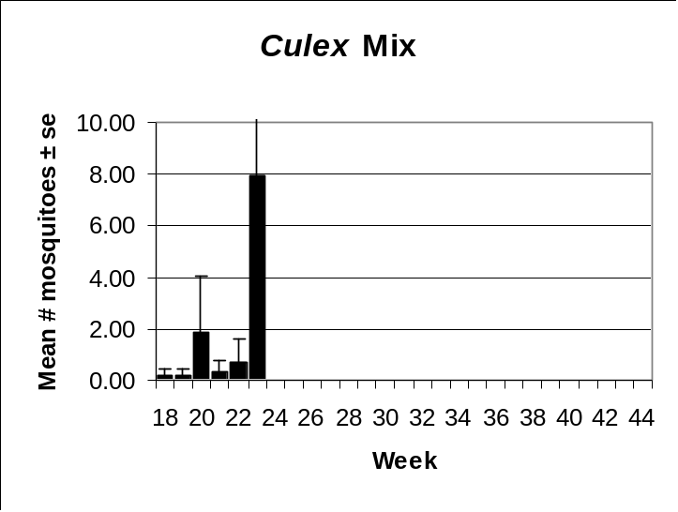
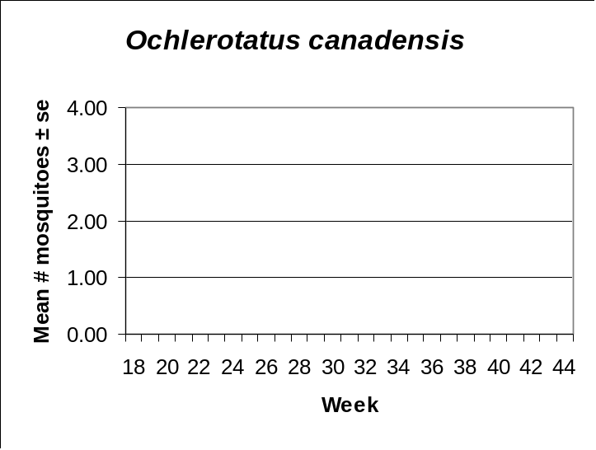 | 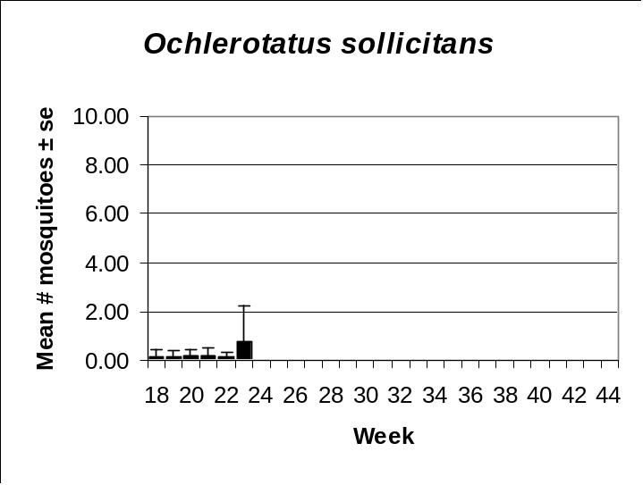

Delaware River Basin
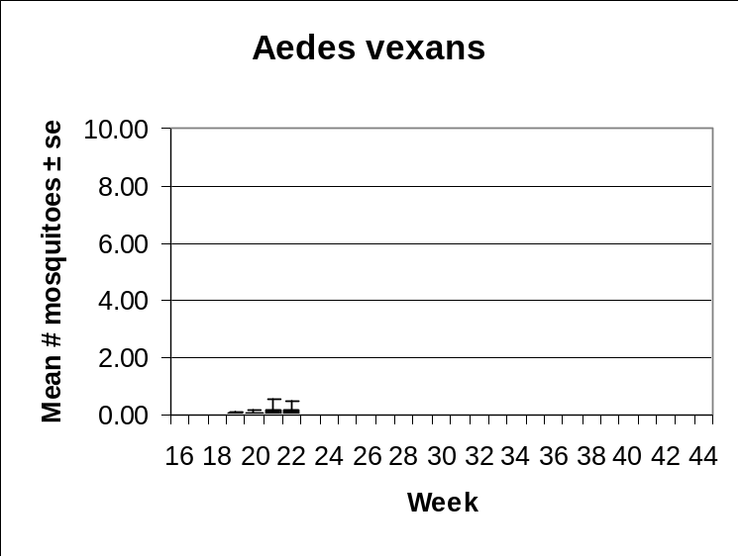 | 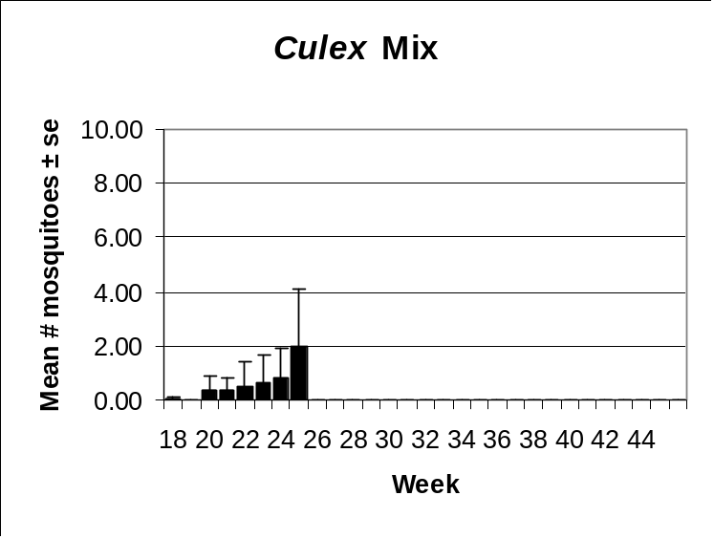
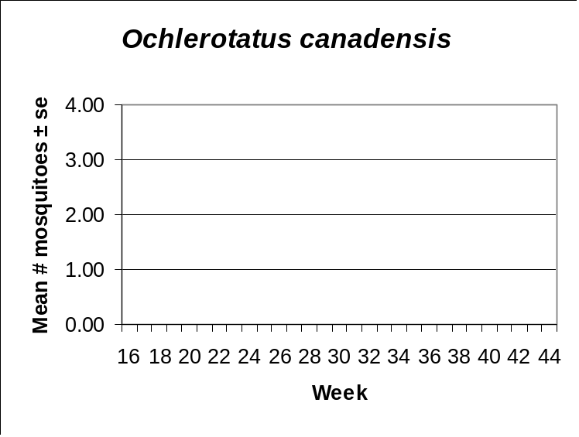 | 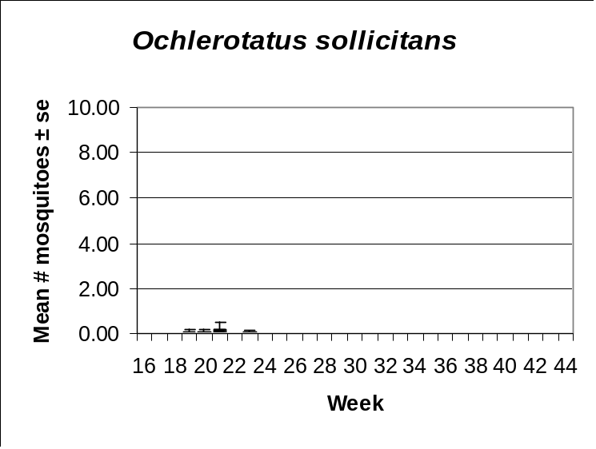

New York Metro
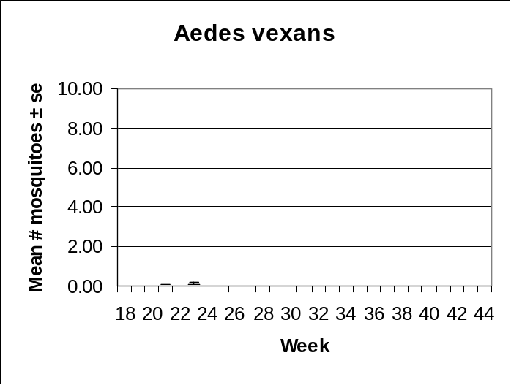 | 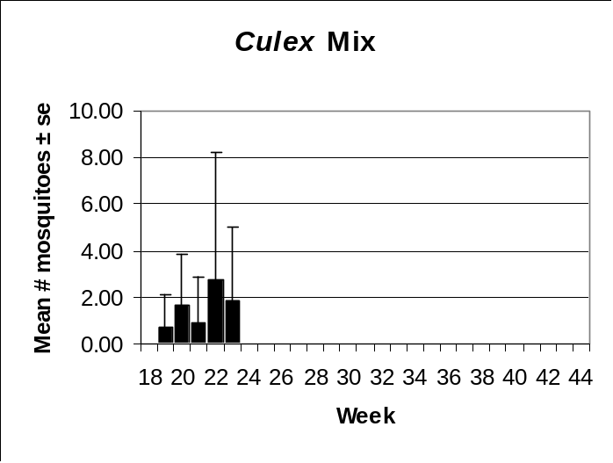
 | 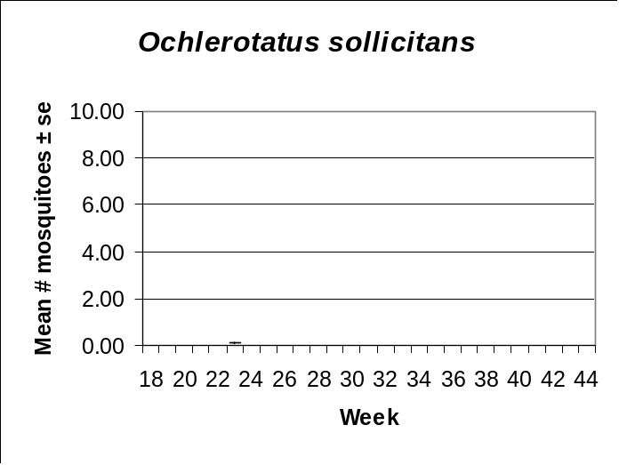

North Central Rural
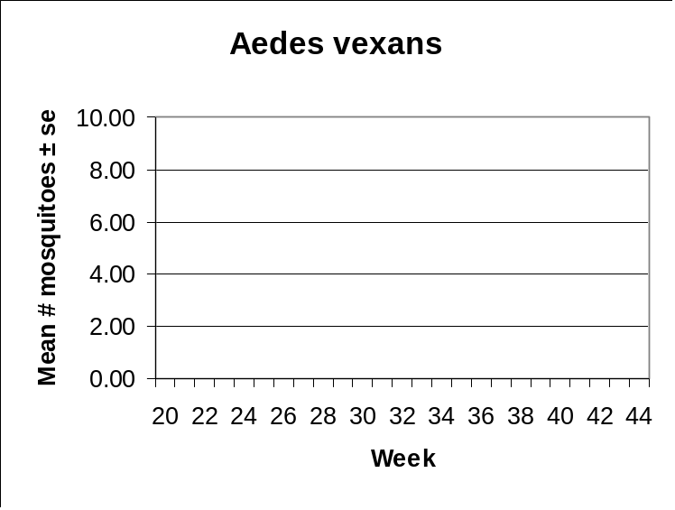 | 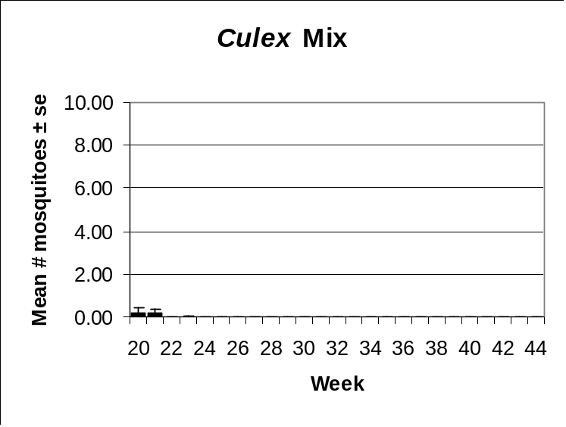
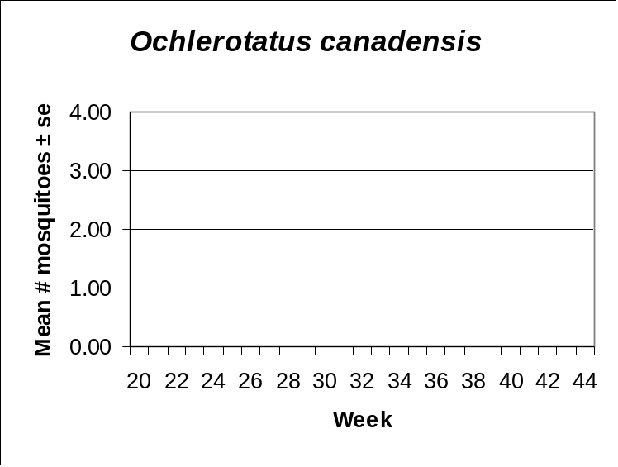 | 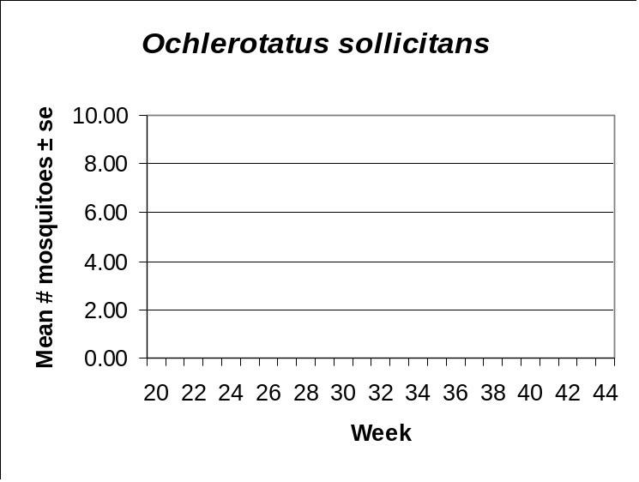

Northwestern Rural
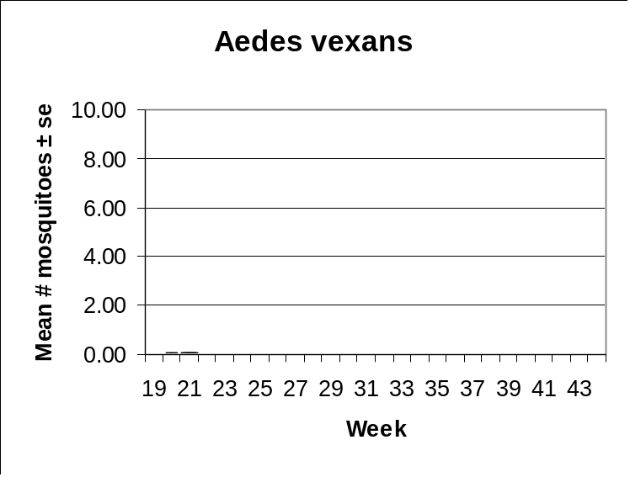 | 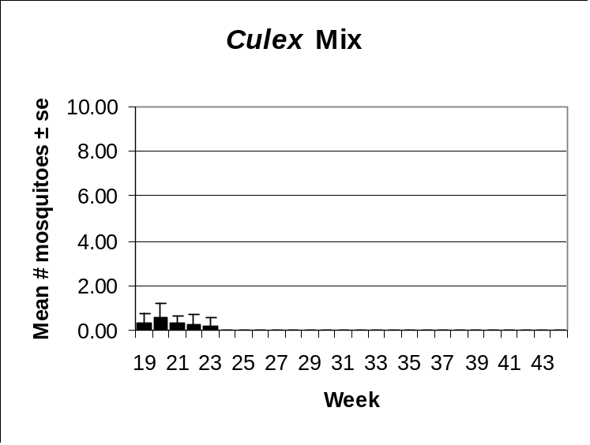
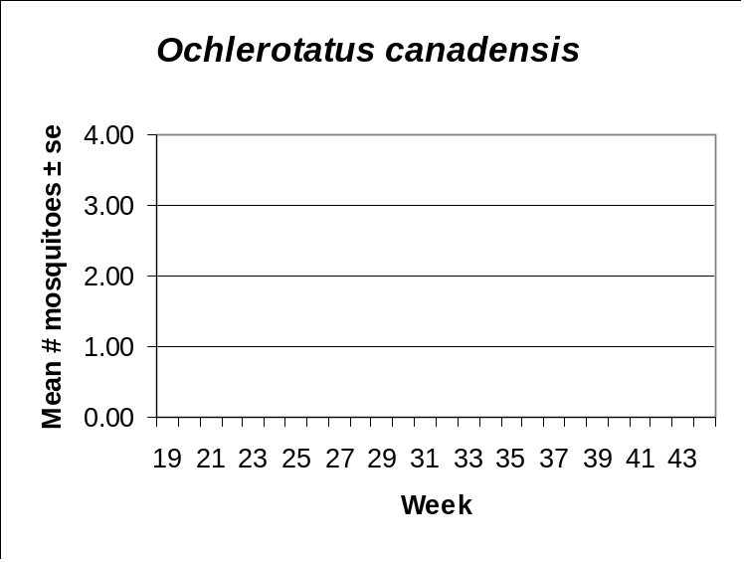 | 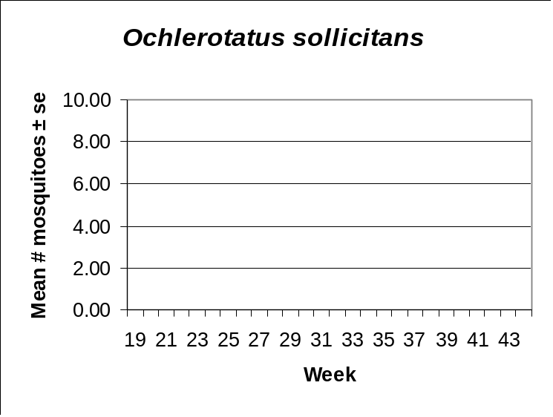

Philadelphia Metro
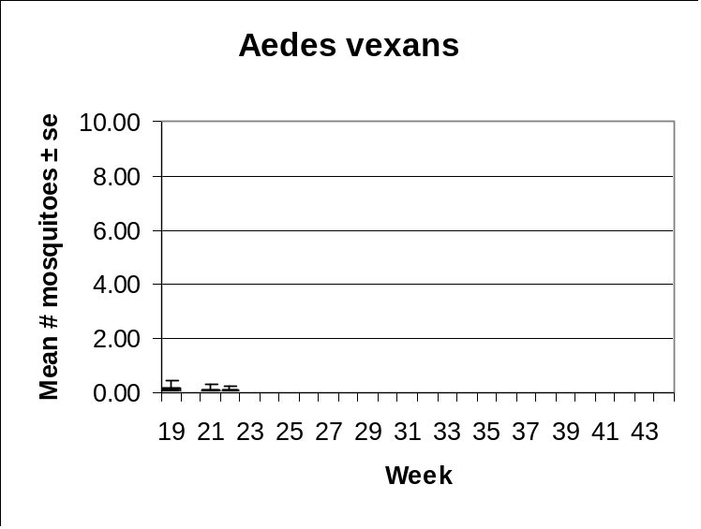 | 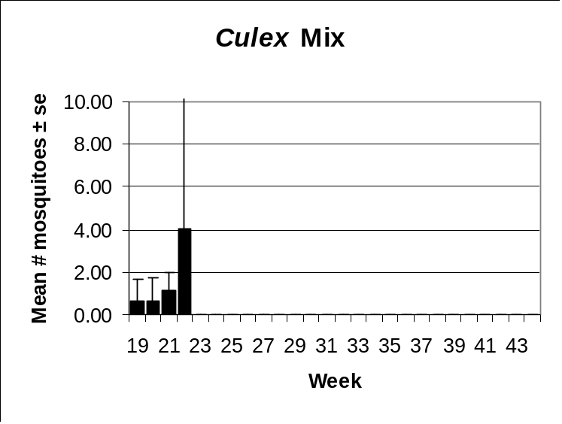
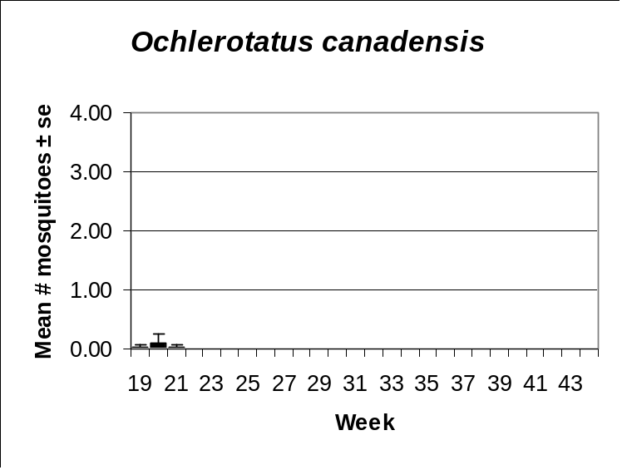

Pinelands
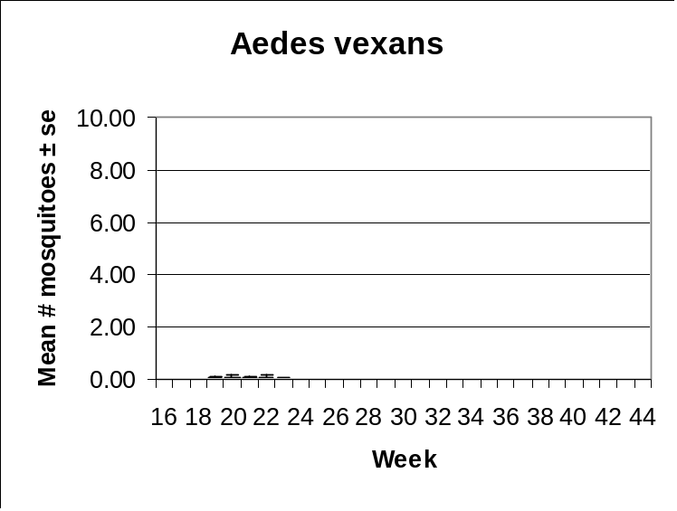 | 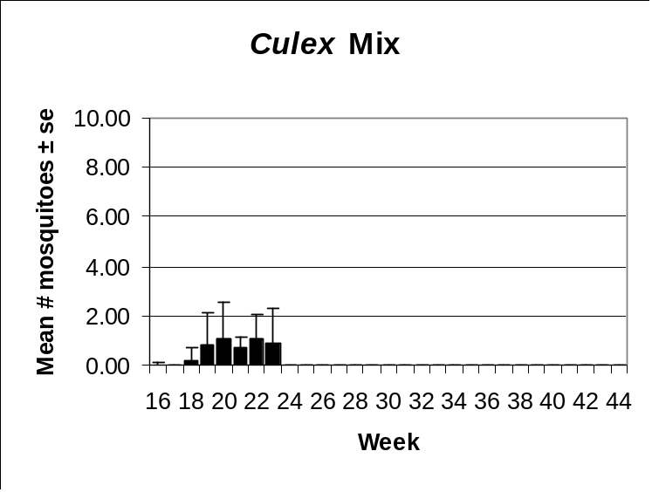
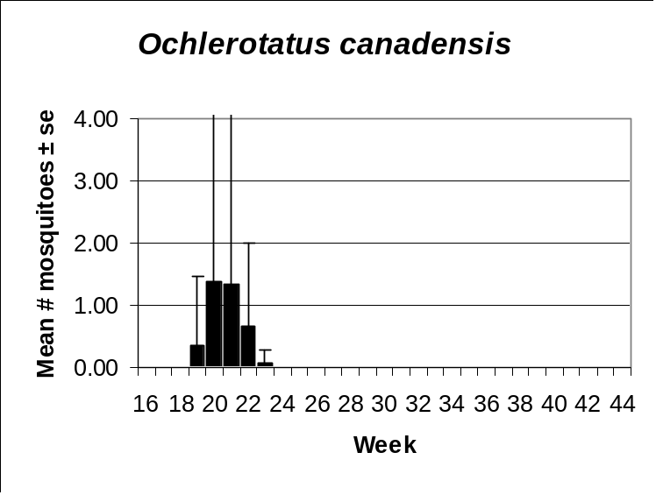 | 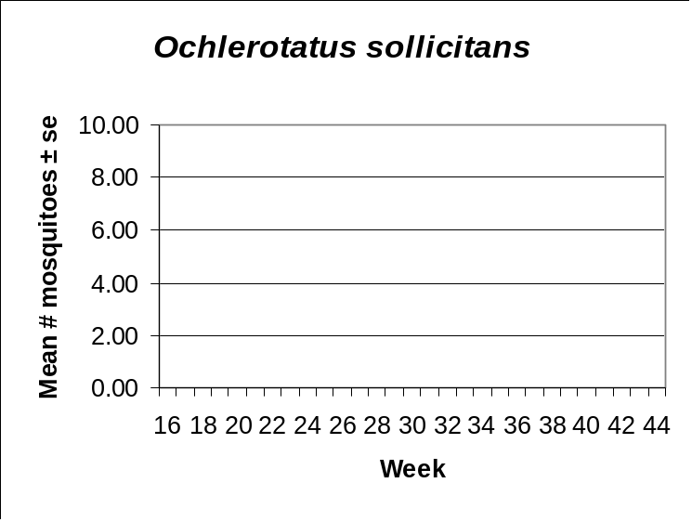

Suburban Corridor
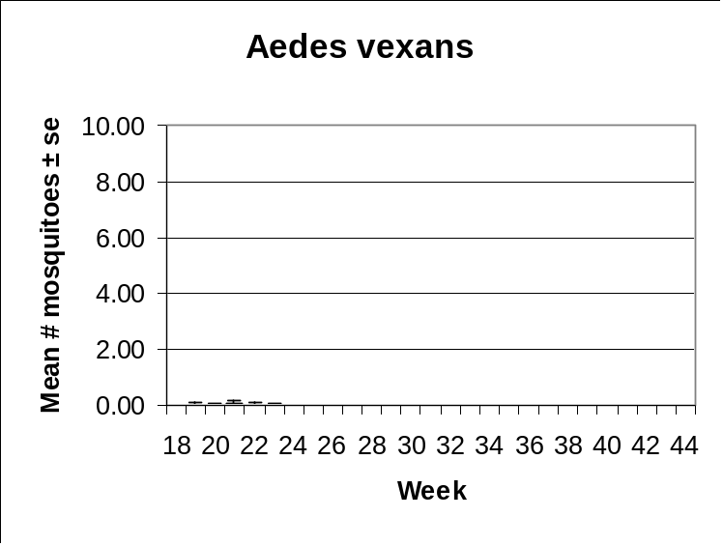 | 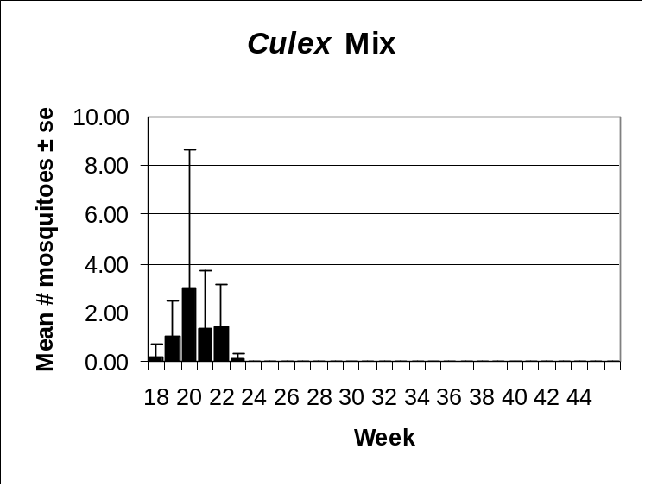
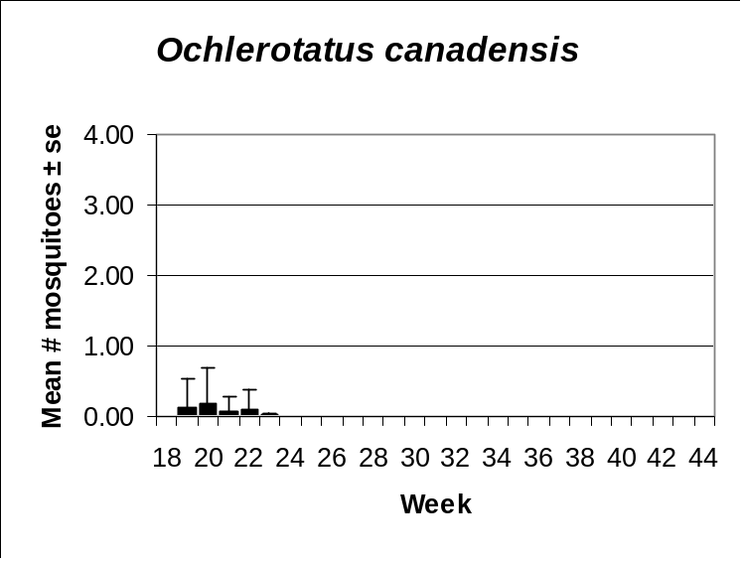 | 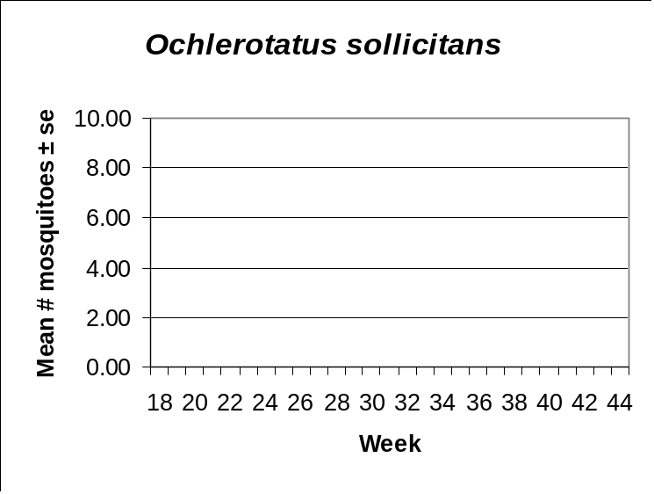

Aedes vexans
Agricultural | Coastal | Delaware Bayshore | Delaware River Basin
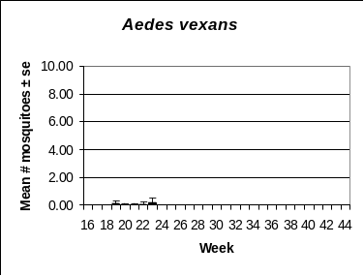
New York Metro | North Central Rural | Northwestern Rural | Philadelphia Metro
Pinelands | Suburban Corridor | Comments
 |  | Ae. vexans populations do not normally reach nuisance levels until later in the season. The early-season data for 2003 clearly show that no major broods have emerged to date. The amount of rain New Jersey has been experiencing this year is probably not reflective for potential floodwater nuisance. Temperatures for the month of May were lower than normal and rainfall has been continuous, with little opportunity for dry down and egg conditioning for repeated hatches.

Culex Complex
Agricultural | Coastal | Delaware Bayshore | Delaware River Basin
New York Metro | North Central Rural | Northwestern Rural | Philadelphia Metro
Pinelands | Suburban Corridor | Comments
 |  | Data for mosquitoes in the Culex Complex show real trends in most of the regions being monitored by this program. Culex populations normally build as the season progresses. Sharp depressions are often an indication of control intervention. Culex from the Delaware Bayshore, Delaware River Basin and Coastal Regions are probably Culex salinarius. Culex populations from the two metropolitan areas are primarily Culex pipiens/restuans. The Culex populations from rural areas are probably dominated by Culex restuans, considering this species’ ability to utilize standing ground water left over from flooded woodland pools as facultative habitat.

Ochlerotatus canadensis
Agricultural | Coastal | Delaware Bayshore | Delaware River Basin
New York Metro | North Central Rural | Northwestern Rural | Philadelphia Metro
Pinelands | Suburban Corridor | Comments
 |  | Oc. canadensis is an early-season mosquito that reaches highest numbers in early spring. This year’s dataset shows exceptionally low population levels considering the amount of rain we’ve had this spring. This is probably due to missing data points from key counties, particularly those in the northern half of the state. Populations appear to have peaked mid-May in 2003. Highest numbers were reported from the Pinelands region where extensive woodland pool habitat is found. The most accurate indicators for this species have come from geographic areas where we have reliable data. A clearer picture of Oc. canadensis cannot be known until our dataset is complete.

Ochlerotatus sollicitans
Agricultural | Coastal | Delaware Bayshore | Delaware River Basin
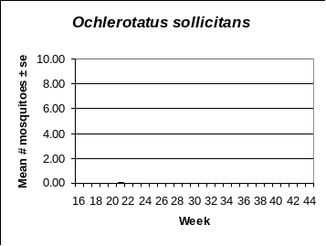
New York Metro | North Central Rural | Northwestern Rural | Philadelphia Metro
Pinelands | Suburban Corridor | Comments
 |  | Oc. sollicitans populations do not normally peak until later in the season. Minimal numbers are being reported from the three coastal areas that provide habitat.

